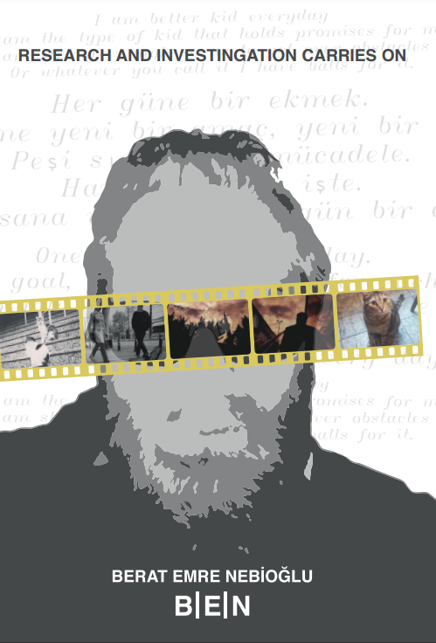

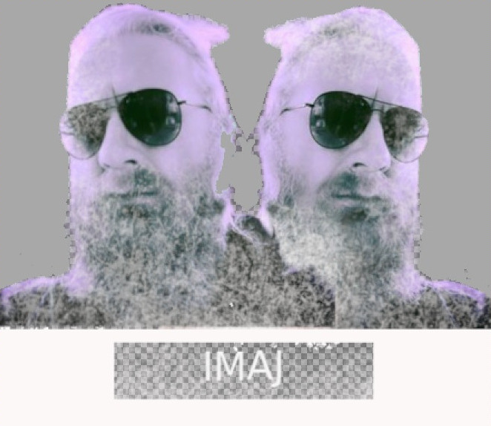

2

My Lifelong Masterpiece: IMAJ

This book mainly consists of 2 parts. Those parts are writing and photography. This book has come together after roughly ten years of hard work. I can safely say it is my lifelong masterpiece.

IMAJ is just a catchy phrase that I use, where research and investigation carry on. Actually, there are many places in life where the word IMAJ suits me well. What you write, what you compose, what you imagine constructs something that is called one of IMAJ in life. Besides this, IMAJ can be used as literal or metaphorical.

The purpose of this book shows up right here: to convey a

3

message, to create some ideas, to manipulate reality, etc. More precisely, reflecting different angles from one’s life so that it can be interpreted with your horizon. I am a drummer. The conversation that brings a specific idea to the table, is, "This is the Berat who wrote that, who made it whole," makes Berat an IMAJ here.

In this book, you will see my writings that contain my imagination, my feelings, my everything. And there are also photographs with some inspirations that make me write short stories about it. Also, some others.

1

[1SpinningCat](https://github.com/spinningcat) is a nickname with a meaning. Like a cat chasing its tail, I’m constantly chasing ideas, building scenes in my imagination. This whirlwind of creativity is what you’ll encounter throughout this book.

4

About book

Love indulging in a delightful daydream? This book is brim-ming with them! Filled with captivating images, poems that delight your senses, and tales that transport you on exciting journeys, it’s akin to stumbling upon a treasure trove over-flowing with enjoyment.

Notice the images? Each one narrates a tale - scrutinize closely and follow where it leads you! Then, immerse yourself in the stories. Encounter new companions, unravel myster-ies, and unearth astonishing wonders. There’s something for everyone!

There are even poems scattered throughout, like small delights! Some prompt contemplation about life, while others revel in the joyous moments. They all contribute something unique, leaving you with a warm feeling inside.

This book caters to all, regardless of age. It resembles a vibrant kaleidoscope of hues and voices, certain to ignite your imagination and leave you yearning for more!

5

Special Thanks

As I reflect on my life journey, I am filled with gratitude for the remarkable individuals who have shaped me into the person I am today. Each of you has made an indelible mark on my heart, and I am forever thankful for your presence in my life.

To my beloved mother, whose unwavering love and support have been my guiding light through every triumph and challenge, I am eternally grateful. Your strength, wisdom, and boundless kindness continue to inspire me each day. Though you may no longer be with us, your spirit lives on in every cherished memory and cherished lesson you imparted.

To my dear father, whose love knew no bounds and whose gentle guidance helped me navigate life’s complexities with grace and resilience, I owe a debt of gratitude beyond words.

Your enduring legacy of courage, integrity, and compassion will forever guide my steps and shape my character.

To my first school teacher, whose patience, encouragement, and dedication ignited my passion for learning and set me on a path of lifelong curiosity and discovery, I offer my heartfelt thanks. Your belief in my potential and unwavering support laid the foundation for my academic and personal growth, for which I am truly grateful.

To all those who have stood by my side, offering a listening ear, a comforting embrace, or a word of encouragement

6

when I needed it most, I extend my deepest appreciation. Your friendship, loyalty, and unwavering belief in me have been a source of strength and inspiration, and I am humbled by your presence in my life.

Lastly, to the friend with whom I shared countless moments of joy and connection at jazz concerts, thank you for the laughter, the music, and the memories we’ve created together. Your companionship has enriched my life in ways I cannot fully express, and I am grateful for the bond we share.

As I envision the future, I hold dear the love, support, and encouragement from all of you. Your presence in my life is an invaluable gift, and I am fortunate to have you as family, friends, and mentors. May we keep walking together, experiencing life’s ups and downs, and may our connections strengthen daily.

7

About me

Hey there, I’m Berat Emre Nebioğlu, and I’m excited to share a bit more about myself with you! By day, I’m a computer scientist, delving into the intricacies of technology and innovation. I thrive on the challenge of problem-solving and the thrill of exploring new ideas, especially in the realm of artificial intelligence.

However, when the workday ends, my world expands beyond the confines of technology to embrace the vibrant realm of art. I’m passionate about various forms of artistic expression, from the captivating strokes of visual art to the soul-stirring melodies of music and even the immersive storytelling of computer game design.

Art, to me, is more than just aesthetics; it’s a medium through which we can explore the depths of human emotion and the complexities of the human experience. Whether I’m wandering through galleries, losing myself in the rhythm of a live concert, or simply immersing myself in the imaginative worlds of video games, I find endless inspiration in the boundless creativity of the artistic landscape.

In both my professional and personal pursuits, I strive to approach each endeavour with an insatiable curiosity and unwavering passion. Whether I’m crafting intricate lines of code or admiring the masterful strokes of a painting, I’m driven by a relentless pursuit of excellence and a desire to continually

8

push the boundaries of what’s possible.

For me, true fulfilment lies in embracing the richness of life’s experiences and constantly seeking out new avenues for growth and self-expression. It’s through this journey of exploration and discovery that I find joy, purpose, and meaning in every aspect of my life.

Thank you for allowing me to share a glimpse into my world with you!s

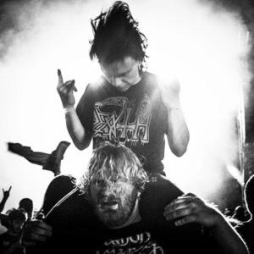

9

My Story make me dive into this world. Some photos have a captivating story. A powerful subset of stories can be visually depicted.

The atmosphere was electric with joy and emotional energy as the crowd seized the moment. The legendary Amon Amarth took the stage, and we were ready to let loose. As the music began, our collective roar shook the venue. Vikings on stage and in the audience alike ignited the night, leaving an unforgettable mark on everyone present.

10

Contents

1 Writings, stories and poems

15

1.1 Research and investigations will continue. . . .

17

1.2 Notes To Myself . . . . . . . . . . . . . . . . . .

19

1.2.1

April 1, 2015 . . . . . . . . . . . . . . . .

19

1.2.2

April 2, 2015 . . . . . . . . . . . . . . . .

20

1.2.3

April 3, 2015 . . . . . . . . . . . . . . . .

20

1.2.4

April 4, 2015 . . . . . . . . . . . . . . . .

21

1.2.5

April 6, 2015 . . . . . . . . . . . . . . . .

21

1.2.6

April 8, 2015 . . . . . . . . . . . . . . . .

22

1.2.7

April 8, 2015 . . . . . . . . . . . . . . . .

23

1.2.8

April 9, 2015 . . . . . . . . . . . . . . . .

23

1.2.9

April 10, 2015 . . . . . . . . . . . . . . .

24

1.3 Notes to myself - 2: I think I’m starting to like

this. . . . . . . . . . . . . . . . . . . . . . . . . .

25

1.3.1

April 14, 2014 . . . . . . . . . . . . . . .

25

1.3.2

April 15, 2014 . . . . . . . . . . . . . . .

26

1.3.3

April 15, 2015 . . . . . . . . . . . . . . .

26

1.3.4

April 15, 2015 . . . . . . . . . . . . . . .

27

CONTENTS

11

1.3.5

April 17, 2015 . . . . . . . . . . . . . . .

28

1.3.6

April 28, 2015 . . . . . . . . . . . . . . .

29

1.3.7

April 28, 2015 . . . . . . . . . . . . . . .

31

1.4 Remember . . . . . . . . . . . . . . . . . . . . .

32

1.5 As human beings . . . . . . . . . . . . . . . . .

33

1.6 ... (Unnamed Note) . . . . . . . . . . . . . . . .

34

1.7 ... (Unnamed Note) - 2 . . . . . . . . . . . . . .

35

1.8 Feeling . . . . . . . . . . . . . . . . . . . . . . .

35

1.9 A Pianist’s Story . . . . . . . . . . . . . . . . . .

36

1.10 I saw a musician on stage the other day. . . . . .

37

1.11 We also have bread... . . . . . . . . . . . . . . .

39

1.12 Like Everyone Else

. . . . . . . . . . . . . . . .

39

1.13 The music bond of the little man, who is a trav-

eller on his own path. . . . . . . . . . . . . . . .

41

1.14 My freedom is mine.

. . . . . . . . . . . . . . .

43

1.15 Going into detail is the greatest painkiller. . . .

44

1.16 A Soul Awaits, Noticed or Unnoticed. . . . . . .

47

1.16.1 First Birth, First Gaze into Life

. . . . .

47

1.16.2 A Baby was Born into the World, a New

Joy Emerged . . . . . . . . . . . . . . . .

47

1.16.3 Being Intertwined with Life . . . . . . .

48

1.16.4 Life, a Process We Grow Into . . . . . . .

48

1.16.5 How Do We Recognize a Pure Soul? . . .

49

1.16.6 To Be a Pure Soul, Certain Things are re-

quired. . . . . . . . . . . . . . . . . . . .

50

CONTENTS

12

1.16.7 One Day, Go Outside. . . . . . . . . . . .

50

1.16.8 Ultimately, the Choice is Yours. . . . . .

51

1.17 The Wine Effect . . . . . . . . . . . . . . . . . .

52

1.18 Crying

. . . . . . . . . . . . . . . . . . . . . . .

53

1.19 The biggest treasures inside me are apparently

hidden in my tears. . . . . . . . . . . . . . . . .

55

1.20 I Am Still Here. . . . . . . . . . . . . . . . . . .

56

1.21 Feeling . . . . . . . . . . . . . . . . . . . . . . .

57

1.22 Shout . . . . . . . . . . . . . . . . . . . . . . . .

57

1.23 I have an Endless Melody and Never-ending Breath. 59

1.24 The Music Connection of the Little Man on His

Journey. . . . . . . . . . . . . . . . . . . . . . . .

60

1.25 Silent Scream . . . . . . . . . . . . . . . . . . . .

61

1.26 Faces...Faces... . . . . . . . . . . . . . . . . . . .

64

1.27 Sometimes looking at a person’s face is enough.

65

1.28 Writing a Text . . . . . . . . . . . . . . . . . . .

66

1.29 I have an endless melody and an endless breath.

68

1.30 Hope . . . . . . . . . . . . . . . . . . . . . . . .

68

1.31 My Angels in the Darkness . . . . . . . . . . . .

71

1.32 A collective poetic essay - Night Swims . . . . .

73

1.33 Elephants and Grass . . . . . . . . . . . . . . . .

74

1.34 Peter Griffin, Eric Cartman, and Gazoz . . . . .

80

2 Photographs and stories

83

2.0.1

Selection and Stories . . . . . . . . . . . . .

85

CONTENTS

13

3 Categoric Selections

122

3.1 Categories . . . . . . . . . . . . . . . . . . . . . 124

3.1.1

City . . . . . . . . . . . . . . . . . . . . . 124

3.1.2

Saturated . . . . . . . . . . . . . . . . . . 132

3.1.3

B-W . . . . . . . . . . . . . . . . . . . . . 144

3.1.4

Animal . . . . . . . . . . . . . . . . . . . 163

3.1.5

Experimental . . . . . . . . . . . . . . . 202

4 Special Selections

241

4.0.1

Honorable Mention . . . . . . . . . . . 243

4.0.2

All Speciality . . . . . . . . . . . . . . . 244

5 Future Plans

319

5.1 Digital Exhibition - 2D . . . . . . . . . . . . . . 319

5.2 Wall Exhibitio . . . . . . . . . . . . . . . . . . . 319

5.3 Photo tables . . . . . . . . . . . . . . . . . . . . 319

5.4 Digital Exhibition - Personal App . . . . . . . . 320

5.5 Digital Exhibition Book - Digital . . . . . . . . . 320

5.6 Digital Exhibition Book - Physical . . . . . . . . 320

5.7 Digital Exhibition Book - Digital . . . . . . . . . 320

5.8 Digital Exhibition Book - Physical . . . . . . . . 320

5.9 3D Exhibition . . . . . . . . . . . . . . . . . . . 321

5.10 Almanac of Memories . . . . . . . . . . . . . . . 322

5.11 Photography App . . . . . . . . . . . . . . . . . 322

5.12 Narrative Endeavors . . . . . . . . . . . . . . . . 322

CONTENTS

14

6 Additional Context

323



15

Chapter 1

Writings, stories and poems

In the world of expressing ourselves, writings, stories, and poems are like old friends. They’re not just words on a page; they’re windows into people’s hearts and minds. Through these, we explore life together.

Stories whisk us on adventures through books or screens.

We meet characters who feel like family and go on journeys that leave us wanting more. They give us comfort, inspiration, and a sense of belonging.

Poetry is like music for the soul. It uses words to create beautiful pictures and emotions in just a few lines. A good poem can make us laugh, cry, or see the world differently. It reminds us that simple words can be very powerful.

From letters to essays, writings show us different parts of

CHAPTER 1. WRITINGS, STORIES AND POEMS

16

human life. They help us share our stories, understand our thoughts, and connect with others. Writing lets us express ourselves deeply.

What’s cool is how these types of expression often mix together. Stories can be like poems, and poems can tell stories.

It’s like a puzzle where each piece fits together to make something amazing.

As long as there are people, there will be stories, poems, and writings to remind us of our shared humanity. They’re not just from the past; they’re still with us today, connecting us and giving us comfort in uncertain times. They show us that we’re never alone in life’s journey.

CHAPTER 1. WRITINGS, STORIES AND POEMS

17

1.1

Research and investigations will continue.

There were those who thought I would give up. Perhaps someone’s conscience was put at ease. Their conscience talked too much to them, The inner voice was all mixed up.

But life was not so CHEAP, It came when it was time to come. It was the moment when you realized, It was one of those moments when the truth would be revealed one by one.

It should not be worried that research and investigations will continue tirelessly, Be assured that everything covered in dirt will be exposed one by one. A mind that is very well-matched with time will make this situation, Sands of time will flow, That’s when the importance of research and investigation will come to light.

In another course of time, When there is a superhuman justice, When the time when justice is fully revealed, Who is standing tall, who is falling will be seen.

Research and investigations will continue, The truth will be revealed one by one. Right or wrong of what has been done will inevitably be judged, But you won’t do it, you’re not human. You are weak.

Some situations should exceed us, There should be divine power or whatever you call it there. Lightning should strike us, winds should blow us from here to there. That’s when we’ll really understand what we’re doing.

Waiting to give up, waiting to submit, Unfortunately, pass-

CHAPTER 1. WRITINGS, STORIES AND POEMS

18

ing through this stage has become fashionable. But it was not a situation that could be forced or followed. However, what happened has been experienced, what needs to be seen has been seen.

Is today over? No, it’s not. It’s 2:30 am, and I’m still standing. My trash metal is playing, my voice inside is getting clearer. The only thing echoing is that research and investigations will never end.

The last question as I bid farewell to these lines: What did human life mean to you as the day came to an end? Can you write a line about the meaning of life? Or do you end your night without writing anything with your pen?

Anyway, wherever you come from, that’s where you’re going. I don’t really believe in the saying "you are what you were at 7 when you’re 70". I don’t fall for conservative attitudes. My way is the way of change, and my direction is different every day.

"I’m on a long and thin road, going day and night," he says.

"You are a worker, stay a worker, put on your overalls," he says. And he says many more things. I say something in this life too.

I take my instrument, my words, and myself and hit the road. I hum something to that time. Let life know that, I always say it, I always play it.

I write down my notes, sing my song. I always carry the

CHAPTER 1. WRITINGS, STORIES AND POEMS

19

taste of freedom with me, I conduct my research and investigations, Then I close my eyes to the day.

1.2

Notes To Myself

In life, I have seen that people can be happy, peaceful, and highly productive. But one day they make a mistake, big or small. Over the years, it grows and becomes something un-manageable. I decided to write these notes to myself to remind myself of that. Maybe someday I or someone else will need it.

I also noted the dates because - I don’t know - but I have a perspective that has been around since my 20s and lasts until my 40s. To publish a "trial" book. Yes, this is one of my biggest thoughts in life. I have many shortcomings, but they can be overcome over a decade. Of course, I will always chase after my life.

1.2.1

April 1, 2015

In life, there is always a wind blowing in one direction. Some people who cannot face their conscience use that wind for their daily interests. Some people stand in front of a great purpose against the wind. When a person who tries to use the wind is causing a storm, while the other person comes into our lives with such a storm that the types of people who try to use the wind are tossed around.

CHAPTER 1. WRITINGS, STORIES AND POEMS

20

1.2.2

April 2, 2015

Two things lie at the heart of our existence: goodness and evil.

We can also express this as constructive energy and destructive energy. Perhaps these two types of energy were present even when the world was just a gas cloud. These two energies are fighting fiercely at the very core of creation. The Far Easterners call these two energies "yin" and "yang". Can Yin or Yang completely silence the other? I don’t think so. There have been dark periods in the world. However, Yin energy has entered from somewhere and defeated Yang energy - just like the sun defeating the night. In short, nature tells us that we can sustain our lives with either Yin or Yang. But if we keep our Yin side strong enough, we can restrict our Yang side. Moreover, we can take the energy of our Yang side for Yin. Then we become unstoppable. But we must not forget that darkness is much stronger, and it is much easier for light to illuminate darkness than for darkness to darken light.

1.2.3

April 3, 2015

In order for people to live this life and make it liveable, they need to find the energy within them and unleash their potentials. No one can say that a person is talentless or empty. It is just not understanding life. First we will understand life.

Then we will ask why we are here. We will see that life is actually a flexible shell and as we find our potential, life will

CHAPTER 1. WRITINGS, STORIES AND POEMS

21

give us a more liveable place. Actually, isn’t it very simple?

1.2.4

April 4, 2015

What life has taught me, actually what I have learned by taking initiative, there are a few things. The first is change, the second is development, the third is being positive, and the fourth is synthesizing all of these in one spirit. My idea gained from my experiences is that our precondition is to be positive.

Being positive opens the door to change in the right direction and brings us inevitable developments. Then it promises a peaceful but productive life which can help other people. I think this was the biggest lesson life gave me. One of the important things in life may be to understand and develop what you know over time and put it into your life in a different, beautiful way. Life will not always go as expected. But when it happens, you will taste victory, see the light and witness the beginning of brand-new days.

1.2.5

April 6, 2015

Actually, I have a lot of curiosity about life. I want to research, learn, understand and convey to other people. It seems to me like one of the most important tasks that life has given me. To be honest, I need to prioritize my curiosities. Maybe I have to eliminate some or leave them for another season, if my life is long enough. But as long as I live, as long as I am healthy

CHAPTER 1. WRITINGS, STORIES AND POEMS

22

- meaning I am not bedridden - I will continue my research.

Even if I become bedridden, I will definitely find a way. Yes, I think my brain, which works continuously and without stopping, has a certain location. Although it is difficult to focus on my own agenda in this world where things flow so fast and millions of information are transmitted, isn’t the real struggle to find out that you are who you are, making choices accordingly, and putting yourself in line with them?

Questions come at that moment from all sides: "What is this effort? Are you going to reach the core of knowledge?" If there is such a core, of course. I believe that the essence of knowledge, or the core, is in utopia, and that worldly creatures like us can never reach there. However, if utopia comes across, I want to be ready for it, even if only a little.

1.2.6

April 8, 2015

I make a lot of comments about life every day. I’m swimming in the probability of the possibility that my comments will actually settle into life. I have always liked swimming in the dark. Did I ever tell you that? You don’t know what’s coming, you’re always on alert, you become more attentive. Your pupils widen. You concentrate on the light particles ahead.

Because reaching those light particles or the reflections it creates has been the biggest goal at that moment. The real question is whether you will feel relief or pain when you reach the

CHAPTER 1. WRITINGS, STORIES AND POEMS

23

light. That’s where the matter really starts. If I have a punish-ment to endure, I am willing to endure it until the end. But if the light will give me relief, then I am eager and willing to reach more.

1.2.7

April 8, 2015

Life is shaped according to people’s actions, thought patterns, and what they do. At least that’s how I think it works. Regardless of what happens, learning, putting what we learn into practice and then continuing to learn more is never-ending.

Johannes Heester, who performs theatre at the age of 107, is just like that. He presents different roles to his audience every time he appears, even though he is 107 years old.

1.2.8

April 9, 2015

I think the biggest lesson we humans should take from life is that we don’t have to be like each other. This difference can be seen in conservative societies or regions where certain approaches have become taboo. But the truth is that as people grow up, develop, become wiser, create awareness, in short, when all of these come together, these taboos or conservative molds will lose their validity. Some people will still try to maintain these taboos as a kind of self-defence or by ignoring their responsibilities. But they will eventually see that those who do not do this will lose their validity. This is the natural

CHAPTER 1. WRITINGS, STORIES AND POEMS

24

but equally merciless functioning of life. What really matters is living. It is meeting new things every day, understanding life, setting oneself for, in short, it is entering the burrow of life and carefully taking the shiny pearl that the hard-shelled clam hides in our hands. We need to do this carefully because our responsibilities are always with us. Respecting each other, understanding that each of us has the right to make our own choices, and seeing that the right to live belongs to that person no matter what. These are our responsibilities. When we fulfil our responsibilities, that hard shell will soften, take on a flexible form, and give us the necessary environment to live.

And we will be happy.

1.2.9

April 10, 2015

Everyone knows themselves, anyway. This process begins with a baby shouting "I am here" unconsciously. The next process is the development process. Everyone is pulling the oars in this process. There is no problem with that. Some people feel that their oar is very heavy, and their arms are about to fall off.

But it is a fact that over time, our arms will strengthen, and the oars will become lighter. So there is no problem. Life has never been rosy. And we have never sold pink dreams, either.

Life was tough. And we were aware of this. A life with so many things going on, and so many spontaneous transitions can never be considered easy anyway. You know what? Life

CHAPTER 1. WRITINGS, STORIES AND POEMS

25

had to be difficult anyway. We all found ourselves in this difficult life. For example, it’s a matter of how honest you are or how dishonest you are. We will always hold the oars with our hands. If we can’t hold them, we will resist the raging seas with our minds. But we will always be honest. We will absolutely not capsize.

I came across a film recently. The name of the film was "Life of Pi". A man who had to share the same place with a Bengal tiger in a raft in the middle of the ocean. Aren’t we all face-to-face with 2 oars, 1 boat, and a herd trying to capsize us in the middle of the ocean? Would it be too exaggerated to liken the compelling events we experience to a Bengal tiger at this point? That’s why everyone knows themselves, anyway. So there is no problem.

1.3

Notes to myself - 2: I think I’m starting to like this.

1.3.1

April 14, 2014

It’s quite ironic that when a child living in Africa with perhaps one in a million of your opportunities can achieve the happiness that you can’t seem to find, it really highlights the fact that many of us are struggling to scratch an itch somewhere in our lives.

CHAPTER 1. WRITINGS, STORIES AND POEMS

26

1.3.2

April 15, 2014

The feeling I have right now is both confident and strong. In fact, I am no stranger to this feeling. If we were to express this feeling briefly, it would be a situation where I felt like I had to come out and show myself to the world during my whole life.

Of course, making choices in life was important at this point. I must admit that I have fallen and struggled many times. Isn’t that what life is all about? But the important thing is that our choices never negatively affect justice. Only then does the feeling I mentioned earlier emerge. Actually, doesn’t it seem too difficult?

1.3.3

April 15, 2015

Analytical thinking is very important. Sigmund Freud is known as the father of analytical thinking in psychology. Sigmund Freud tried to direct his unconscious mind, but he couldn’t do it, I heard. I don’t know if it harmed him to do so. However, excessive analytical thinking may seem harmful. Moreover, approaching every event analytically may not always be wise.

But I am in favour of considering what the problem is, where it will lead, what its side effects will be, and whether it will have a domino effect on the surrounding stones. This can also be done with analytical thinking.

I must forecast to some extent. That is, we should have predictions for the future. We should identify situations well and

CHAPTER 1. WRITINGS, STORIES AND POEMS

27

have scenarios accordingly. Otherwise, are we any different from a headless chicken? We run around aimlessly.

But we must not forget that being analytical separates us from emotionalism. Especially, it takes us far away from ha-tred, arrogance, and ridiculous egoistic obsessions. Of course, we are not robots. We do not emerge from torn underwear like cyberman in Doctor Who or are not robotic beings saying

"exterminate." We are not programmed. We carry both an angel and a demon within us. Perhaps we need to use analytical thinking to find the balance between them. Of course, let’s sprinkle a little emotional intelligence in there too so that we don’t become robotic cyberman and exterminate everything.

1.3.4

April 15, 2015

I really don’t know why I’m so drawn to jazz music. Maybe it’s because of the complexity I see in my own soul. That is, my non-monotonous soul that makes variations causes this. The jazz music I used to listen to at one point was exactly like this.

Only the double bass was played as a standard. Apart from that, you couldn’t tell which instrument would come in and when. Still, there was a harmony. And I was amazed. Then I would say to myself that every part of my soul would come together and create a harmony. I think there is no determin-istic structure in jazz music. It is not possible to predict or foresee what will happen in life after 1 minute. You only live

CHAPTER 1. WRITINGS, STORIES AND POEMS

28

with your predictions and analytical thinking. However, the soul is something completely free of these. Maybe that’s why I like jazz music so much.

1.3.5

April 17, 2015

I think people underestimate life. Yes, indeed, we definitely need to expand our vision. We are stuck within four walls, deceived and distracted. That’s why most people are unhappy and restless, even though we have reached the bottom of materialism. If we knew the potential inside us, or rather if we could find the courage to discover it, there would undoubt-edly be significant changes in our lives. There are two concepts I have learned in this life that shape our way of living.

The first is materialistic life, and the second is metaphysical life. We all want tangible, visible things in this world. There is an English idiom "Face the music" which means to confront an uncomfortable truth, like "face up with inevitable results."

Acceptance is a slow process. "I’m as slow as molases" can also be used. For example, I wanted to own drumsticks. It’s in my library. Some want a house, a car. Some want a jet, a yacht, to scale up and down. But face the music a bit. So, where does this list end? Probably, there is no limit. A human being can become a very ’greedy’ creature. But there is an English idiom, "put your money where your mouth is," which can be translated as "talk the talk and walk the walk". What does it

CHAPTER 1. WRITINGS, STORIES AND POEMS

29

add to our lives? That is, not talking the talk and extending the list more and more. Will any of these matter when you are bedridden? These are questions you should ask yourself every day. "Questions you should ask yourself every day." Money is worshipped nowadays, "worship to money dedicate for gain-ing this small shitty piece of paper or coin". We want beautiful things, beautiful bookshelves. I want to listen to jazz music in my 5th concert series starting from tomorrow’s Jazz concert.

Perhaps the heroes in the books we put on our shelves also want what I want, can’t it be? Do you judge a book by its cover without opening it? Those heroes want a soul. That’s when the other way of life comes into play. Metaphysical life adds new windows to the house you build in this life. So that you can see unseen landscapes. The things you can see in these landscapes give more pleasure than anything you can have in metaphysical life. Of course, balance is a fact that needs to be present in every aspect of life. But do you know? Discovering this point gives us more happiness than anything else. In Plato’s world of ideas, utopia, we will never be there, but we can make our lives better and get rid of monotony. LET’S GET

RID OF IT.

1.3.6

April 28, 2015

Power is very important at home. Knowing your strength, knowing what you are capable of, knowing your limits, know-

CHAPTER 1. WRITINGS, STORIES AND POEMS

30

ing when to surrender, knowing when to let yourself go, seeing and sensing where the inner you can take you. Actually, these are your real powers. The thing called power must be realistic. It should not be inflated too much, or it will burst.

Because as much as a human being is designed as a powerful creature, he can easily exaggerate and become intoxicated with that thing. And then his head will turn into a kind of village idiot, neighbourhood bully. That’s when he loses his power. Therefore, power must be sought within oneself. More precisely, things that can bring out that power must be found.

Only then can you show the light that your power spreads to yourself and to those around you. There are many examples that can be given at this point. Let me limit it to just 2 with your permission. Let me start with a musician whose concert I recently attended. She is a 60-year-old percussion artist who came to our country with the concept of performing in 60 places this year, celebrating her 60th year. She is like a sycamore tree with long branches and green leaves, proving the opposite of what people have become in 60 years. How she performed for us was simply amazing. She played drums, used her percussion masterfully, played the piano, and even sang. Her voice was hazy. You look out of the hazy glass; it’s snowing outside. You admire it. That’s exactly how she was.

Her name was Marilyn Mazur. Also, let’s give an example of a theatre actor from our country. Genco Erkal was amazing on

CHAPTER 1. WRITINGS, STORIES AND POEMS

31

stage. He knew how to use his voice beautifully. His octave must have been high. Yes, it had to be. He could transition quickly from a deep tone to a light one. His diaphragm must have been very strong. He also seemed to have control over his head voice. And what about his voice frequency? When he spoke loudly, you would suddenly hear him transform into an almost inaudible tone. Here are two giants who have found their power but remained human! It is a fact that we humans need to get our act together. This is a heavy slap that hits us in the face every hour of our lives. The truth is, there are so many examples out there that we can learn from if we just open our eyes a little bit.

1.3.7

April 28, 2015

Life doesn’t always go the way you want it to. However, you shape yourself according to the evolving situations, much like water taking the shape of its container. Of course, at this point, being principled and honest is i mportant. You should know that life will end someday, and you will inevitably face this reality and embrace it. This will help you a lot in life. We are the ones who make life complicated; then we start saying that life is meaningless. This is because we cannot untangle ourselves from the complexity. For example, after putting my headphones in my pocket for a while, I notice that the cables are tangled. Until I solve it, I become frustrated. In fact, it is

CHAPTER 1. WRITINGS, STORIES AND POEMS

32

very easy for us to get into knots that cannot be untangled in life. In short, life will always try to tie this knot for you. You need to know this and act accordingly.

1.4

Remember

Life can be beautiful, We must not give up. Who knows what tomorrow will bring, We must be cautious. Opportunities can come at any moment, We must do our best. Death can also come at any moment, We should not leave with our eyes open.

Remember!

Life is a temporary passion, But your existence is a process that opens up to eternity. Your existence is always there, yes-terday, today, and tomorrow, But what is really important is today. Today is that day! Today is the day your existence was gifted to you. Make good use of it. Do not sigh for your past, do not miss your future, Because tomorrow will be another

"that" day. Remember!

Fight until you drop, Strive for your life, be worthy of it!

Even if your efforts do not yield the desired results, fight tirelessly. Most battles are dirty and damaged. Remember!

One day you will close your eyes. Two drops of tears from your eyes when you close them, Maybe it will contain a solu-tion for life. Do not waste your tears! Like everything in life, it should have a meaning. Never forget this!

Remember to make your tomorrow beautiful, Remember to

CHAPTER 1. WRITINGS, STORIES AND POEMS

33

smile at your past, Remember to decorate, paint, and colour today with the beauty of your past and the dreams of your future. And remember that your life should be meaningful enough to fit in two drops of tears, And meaningful until they dry on your cheeks. Never forget these, Remember that others will write these lines in a different way, in another life.

1.5

As human beings

We all live in the same place, as human beings. We eat, drink, sleep, pray, yet we continue on; we move forward with our fantasies, whether they come true or not. We write our script into the void and act as individuals. We lived through our past and look to our present, but I don’t know what we will do for our future.

Maybe we paint for tomorrow, maybe we write notes or stories. Perhaps we even compose music. We are trying to decide which instrument fits best with our composition. Maybe we categorize instruments based on our emotions. We have our violin, cello, bagpipe, electric guitar, bass guitar, and drum set. We also think about what else could be out there and we know that any other instrument could pop up at any time. We must do our job properly and place something correctly into this world.

Despondency and destruction are everywhere. Maybe humans are naturally found in these situations. Everywhere is

CHAPTER 1. WRITINGS, STORIES AND POEMS

34

covered with lies and bigotry. We should ask ourselves "Why is this so?" Instead of preparing the ground for evil. We could go towards a bigger decline without knowing our limits. Wasn’t the biggest sign of the apocalypse the downfall of humanity?

Maybe we weren’t even aware of it. Suddenly we went down to a level even lower than animals. Did we ever ask why, or did we just try to infect others around us with our own col-lapse? Did we become the Antichrist? Or Gog and Magog?

Could we still be a messiah? Is there a way for this?

Of course, there is. Painting, making music, or sculpting will save us. We will find friendship, sincerity, and honesty at the tip of our pen. The notes in the corner of our soul will give us rhythm. Should it be 4/4 or 13/8? Do we have to go straight on a path? Should our rhythms be irregular? I don’t know. The only thing we know is that people surround themselves with lies and deception. The place of honour has been replaced by dishonour, the place of dignity has been replaced by undignified behaviour. This is exactly where the beginning of the end started. This is what we need to remember as human beings.

1.6

... (Unnamed Note)

The roots of some things have dried up, Those things with their heads bowed down, No matter how much water you give, they can’t get the oxygen they need, Completely finished,

CHAPTER 1. WRITINGS, STORIES AND POEMS

35

dried up, and exhausted.

1.7

... (Unnamed Note) - 2

These days, I know a lot about my life. I wiped away the tears that flowed from my eyes. I pour them into my soul and burn them. They can no longer come to my eyes, they cannot shine from my cheeks. They cannot tire my soul, they cannot push me deep down every moment, they cannot drown my soul. I think I closed my eyes to something. I don’t see, or maybe I don’t want to see the truth. Nevertheless, I carry those tears that have dried up in my soul, all the truths. The experiences are going away, never to return. Still, hoping to taste life, I live.

1.8

Feeling

You will surely feel sorry for the people who have died. People are like leaves on a tree branch. When autumn comes, the leaves fall to the ground. When people die, it means our autumn has come too. We lose a part of humanity. We feel in-complete, as if we have lost a soul. Humanity is dying. There is a soul that cannot understand how your eyes will feel when you see it. It struggles and struggles. If a person dies, they are gone. It is a life that has been lost. Especially when you hear about events that say: You could be next in these coming days.

You feel like you have already died. It’s like a rehearsal. For

CHAPTER 1. WRITINGS, STORIES AND POEMS

36

the last 4–5 months, these eyes have seen nothing but death.

Even if I were to die in Paris, I wouldn’t care if the world is hypocritical. Don’t we already know this? Aren’t we used to it? I really don’t know how I feel. The days when humanity still existed, and the days when we knew what it meant to live like a human being, are both coming back to us. They are getting further and further away. Damn it.

1.9

A Pianist’s Story

In the calmest corner of the world, a man lived by himself. He had his own world, his own experiences, and desires burning in his soul every day. He couldn’t hear or see anything and was almost completely paralysed. The instrument he owned to express his longing and desire was a piano. His fingers were his l ifelong companions and friends. Sometimes, his piano was his lover, sometimes his closest friend. As a result, his piano was his most precious treasure.

When this man sat down at the piano, the piano and its keys came to life and provided him with the most beautiful moments of his life. When he began to play, the beginning and end of many stories played out in his fingers and the vibra-tions that came from his soul. When he played, people felt like they were in heaven, declaring their love to their beloved or burying all their anger in the ground and starting life anew.

When he was at the piano, people were drawn to the ports

CHAPTER 1. WRITINGS, STORIES AND POEMS

37

where the pianist’s soulful feelings approached. And as long as he was there, other people were there too.

This man was a beautiful pianist. Not being able to experience many things wasn’t very important to him. His piano and the notes he played were like a messenger bird that carried the needs of the souls around him. The magic of those moments was the most beautiful moment of his life, and he didn’t want anything else. For him, the compositions that emerged there were his piano, his music, and the souls he conveyed his music to.

1.10

I saw a musician on stage the other day.

I went to see a live music group for the first time in a long time, There was a feeling inside me that accompanied me, And it was saying, "You will see a musician there who will tell you about yourself." And it really happened, I saw a musician who told me about myself.

He was playing the electric guitar, at one point he took a classical guitar or an acoustic one, I couldn’t be sure. But it was an indisputable fact that the instrument had no meaning.

The instrument was just an extension of him, he had merged with it on that stage. He could treat his instrument as a part of himself. The musician I saw on stage.

He was standing upright on that stage, you couldn’t pass through his air. But actually, you know what, it wasn’t like

CHAPTER 1. WRITINGS, STORIES AND POEMS

38

that. The man there was just making love to his instrument.

That’s why the musician I saw on stage was very important to me.

At the end of the night, that musician was still on stage with the same upright posture, scanning the surroundings. He took his instrument off his shoulder and calmly put it down. Then he got off the stage, there was still the satisfaction of that night in his walk. It had spread all around him, I said to myself I saw a musician on stage, And that musician was reflecting me, something inside me was matching what he was telling on stage. I was painting a proud and honourable musician inside me.

CHAPTER 1. WRITINGS, STORIES AND POEMS

39

1.11

We also have bread...

Every day, I scratch through life and see that We also have bread. One bread for each day. Freshly baked, crispy, and warm bread.

As I prepare to say goodnight to today, As I prepare to bid farewell to the day I lived, I want to say that you have fed me.

I won’t go to bed hungry tonight. You have fed me bread. May God be pleased with you.

One bread for each day. A new purpose, a new pursuit for each day. A struggle that comes one after the other. This is life. Life gives you a bread every day.

I bid farewell to today, I close my eyes. My back is straight, my stomach is full. I will explain it again tomorrow. I will live with the taste of bread. The day will end again. And I will finish my bread again. On the new day, I will eat bread with different flavours.

Bread, bread, bread... We also have bread. One bread for each day. Warm, fragrant bread.

1.12

Like Everyone Else

Like everyone else, I am writing my own novel as the pro-tagonist of my own story. I walk on an endless road with an uncertain end, often looking back and complaining to myself during the rarest moments of y life. Although I bring to mind

CHAPTER 1. WRITINGS, STORIES AND POEMS

40

things that are almost yellowed and forgotten, which have been standing on dusty shelves for a long time when I look back, there is a creativity in the characters I will create in the rest of my life and how I will wear them on me. Just like the creativity that exists in the idea of a novel writer going back to the back pages of his book to make it more exciting and provocative in the future.

That novelist talks about finding someone in part of the novel, just like everyone else. He speaks in line after line from that section about something that will add a lot to his novel or rather, a value that will actually be added to himself as the hero of his own novel. In fact, he is looking for a specific person. The novelist imagines that person will be someone like Peyton Sawyer from One Tree Hill. He wants her to be the essence of his life. Then he looks back again. He sees all the Peyton Sawyers in his life. And suddenly he thinks,

"Those Peyton Sawyers have always intertwined the lines in his novel, messed up the order of paragraphs." And now he takes his pen, a little thoughtfully and cowardly, starts drawing a picture. He draws the picture with those words that are simple, mysterious, timid, but also dedicated to overcoming that fear and even creating new fears and timidity.

That novelist begins to draw the picture, and where the drawing will go is a new Peyton Sawyer. He starts the lines neatly. But as those lines increase, his fears grow, and he has

CHAPTER 1. WRITINGS, STORIES AND POEMS

41

to open up and open his heart. It’s as if those lines of text are constantly saying, "come to me." At that moment, the novelist tries to adapt to a new world like a being who has stepped into a new creature. But in this situation, he sees many more lines of text. And he knows that when those lines of text come together, the meaning that will be created will fall behind love, and it will mean that it will never come back again. But still, he stubbornly writes, writes, writes... Just like everyone else...

Then he realizes that the novelist, like everyone else, "I am also the toy of my own novel."

Actually, he understands at that moment that "I am the toy of those lines of text."

Actually, he realizes that he is "his own toy" in reality... Like everyone else...

1.13

The music bond of the little man, who is a traveller on his own path.

The story is about a little man who had created his own path, composed his own melody, designed his own story, and shaped his own stage.

He wanted to appear big in front of life and tried to take all his steps accordingly, expecting life to be merciful to him.

He didn’t know how merciful life would be to him, but he knew how to rewrite the notes. He could create harmonies in 11/8, 6/8 or 3/8 meters or other measures.

CHAPTER 1. WRITINGS, STORIES AND POEMS

42

He created the melody of every day and embraced it as if he was protecting himself. Music was very important to him, maybe more important than anything else.

Actually, what he thought was to find music within everything. Whatever he did, he eventually found the music he wanted. Recently, the souls that made him cry, laugh, be en-thusiastic, and increase his motivation were given by music.

I guess he would do this throughout his life because he believed that life could not exist without music, and deep down, he made this thought the only motto that would support him in his life.

Music was a flower blooming quietly for him. Music was everywhere for him because he knew how to listen and wanted to spread its light around.

There were times when he forgot music, lost it inside. Because sometimes life was being harsh on him. When he lost music, he experienced feelings of disappointment, anger, and resentment. In short, he experienced anger, nightmares, and ugly memories in his life at that moment.

In time, he found his music again. He rediscovered what he had thought he had lost inside. It turned out it had always been there.

Now he could listen to his surroundings, understand them, read them, and write his melodies. He collected those melodies in his book.

CHAPTER 1. WRITINGS, STORIES AND POEMS

43

And he woke up to a new day and continued the same way.

1.14

My freedom is mine.

My freedom is mine. I express it myself. I find my own paths.

I constantly search. Perhaps freedom is something I deserve.

This was the point I wanted. I have reached that point too.

My freedom is my rightful possession. If I didn’t deserve it, these days wouldn’t have come. It could be thought that freedom could be restricted by pitiful worldly means. No, it cannot be restricted. Not understanding this is a silly situation. Because freedom is a person’s right. It is something they deserve. Freedom is earned. It is not something one person gives to another.

My freedom is my conscience. I will always be at peace with life. I will not allow any anger to prevent me from continuing.

I will never wear it out, I will not let it wear me out. Even if you were to confine me with pitiful worldly means within four walls Even if my whole life were spent there. My conscience will travel all over the world.

My freedom is my forgiveness, hidden in my prayers. No matter what, I will pray for everyone. My prayers will not only be for myself. I will cry for everyone, not just for myself.

I will never stop doing this. But do you know? The day will come, and it will be said.

My freedom is my desire for everything to come to light.

CHAPTER 1. WRITINGS, STORIES AND POEMS

44

The day will come when things will not be said out of thin air.

The day will come when truths will come to light. The day will come when everything will be presented with evidence.

Perhaps the evidence will be our own words. The day will come when what is necessary will be as it is said in the next continent.

My freedom will be my reaching the conclusion. The conclusion will definitely be reached before death comes. Nothing will be forgotten, nothing will be added. This will be the greatest indication of my freedom, Being the person who dis-plays the same stance every second of life. This way, the conclusion will surely be reached. DEFINITELY.

1.15

Going into detail is the greatest painkiller.

Music is like a dance floor where details come together and dance in harmony. Only someone who goes into those details can find themselves within that dance, making those figures and moving on to another stage. This is actually the biggest painkiller for them.

For example, when someone has a headache, all they do is focus on one place and stay there. They only think about the headache; then they complain, regret, sometimes even swear.

Some people do this because it’s easy. But instead of making that choice, that person needs to go into the details. Going into the details is the greatest painkiller. The highest form of these

CHAPTER 1. WRITINGS, STORIES AND POEMS

45

details is found within music. Music carries such epic details that sometimes you just focus on that and forget everything else. You exist only in that world and only care about what exists in that world. You exclude others. Why not exclude them?

Right now, that person feels that their pain is disappearing.

And they see that they are losing their existence because they are going into the details. And let’s not forget that going into detail is the greatest painkiller.

"Going into detail" is not an easy process. The prerequi-site for going into detail is to face a great challenge. In other words, concentration is the greatest battle you fight with yourself in your inner world. Generally, people choose to be vic-tims of concentration situations that come and go instantly, whether they want to or not. However, the need for choosing another path is as clear as day. Another definition of another path is: "to let yourself completely surrender to that flow and follow the unimaginable thing that you think will never leave you, that will cling to you tightly in your abstract plane, called

’concentration’." That’s exactly what we mean by another way.

When a person achieves this sincerely, it is time to go into the details. Going into the details will be "a collection of sentences brought out without cerebral masturbation, as a result of the revelation of the impulses in your inner existence and the merging of the existence we defined as ’concentrated’". It can be understood from the processes included in the defini-

CHAPTER 1. WRITINGS, STORIES AND POEMS

46

tions we gave how difficult and complicated this process is.

But let’s remember again: "Going into detail is the greatest painkiller" and believe that it is a tolerable process. We will know that we have a natural painkiller in our hands when we complete this process and feel stronger.

As we said at the beginning, the most epic details are found within music. Let’s talk about it a little bit more. When you listen to music, you see a lot of things that have been worked on and pondered over. Of course, I assume that you have successfully passed all the tests mentioned above. If the music is something that allows you to attain concentration and the power to go into detail, then it is a "legendary" string of chaos that carries your spirit, your sorrows, your smiles, speaks the sentences your soul wants to say and helps you spread them all over the tangible world. And it is also the thing that contains the codes in your brain, enables you to see your brain’s command chain, shows your thoughts and thought structure to the whole world through the instruments you use. That’s why the sentence "contains the most epic details" is because it contains so much in it. To begin with, I want to connect this with a sentence: "When someone has a headache, all they do is focus on one place and stay there." At this point, when you take a glance at the legendary stories in the music after passing the tests mentioned above, do you see how much you have done and how much you have gone into detail? And do

CHAPTER 1. WRITINGS, STORIES AND POEMS

47

you see that going into detail is the greatest painkiller? Actually, the greatest painkiller is "freeing yourself from monotony and dividing yourself into many pieces in a specific area, even though your thoughts appear to be scattered here and there.

If music can provide this for you, it is tailor-made."

1.16

A Soul Awaits, Noticed or Unnoticed.

You have a soul waiting for you, whether noticed or unnoticed, it’s there.

1.16.1

First Birth, First Gaze into Life

We all come to this life with a pure soul. We have blank pages to fill. We scrutinize life with our eyes. How innocent and pure we are, unaware, looking without consciousness. We cry.

We scream as loud as we can. Is it the happiness of coming into this world or the regret of being born into it? We don’t know these things. Because we have just met life. Our soul, engaged in a spiritual handshake with life, makes its first con-tact. Everything is so clear at that moment, as I said, we only exist with our soul at that moment.

1.16.2

A Baby was Born into the World, a New Joy Emerged There was a baby who didn’t know what to do. Very pure, yet so naive, it touched life. It looked around with its eyes.

There was a convergence at that moment, and something

CHAPTER 1. WRITINGS, STORIES AND POEMS

48

symbolizing that convergence. The baby’s crying, or rather, its screams. Who knew what those screams meant? Was it Joy? Or Sadness?

In my opinion, it was a great joy. Because it came into the world with a pure soul. It had set itself a clean purpose. Its eyes were sparkling. It was saying, "I’ve come to life."

Perhaps its cries were a note. It was touching life through them. From those notes, eventually, a music would emerge.

Whether it would be a dissonant music, grating to the ears.

Or it would be a masterpiece, giving peace to humanity. These would be understood over time.

1.16.3

Being Intertwined with Life

Actually, it’s a lifelong process. We all get involved with life.

While struggling, we can either be destructive or constructive.

Actually, we do both. We need to realize that. None of us are clean. The important question is, how clean are we? As the song says, "None of us are innocent."

1.16.4

Life, a Process We Grow Into

It’s a period where our soul either ascends or sinks into the swamp. The choice is ours, we humans’. Life itself isn’t quite clean.

Yes, life itself isn’t clean. There are many traps. We can stumble and fall at any moment. The biggest trap is being a

CHAPTER 1. WRITINGS, STORIES AND POEMS

49

captive to ourselves. Do you know what dirties our souls the most? Our minds and the games they play on us. As it’s mentioned in one of the books, don’t be a captive to your mind; involve your soul in life.

Recognize your feelings that will lead you to disaster. Always be at peace with them. Knowing what you harbour inside. But live without surrendering to them. Live so that you won’t be dragged into the swamp. Because the swamp will drag you deeper. It might be difficult to dry the swamp. And while sinking into the swamp, you can’t dry it. So, don’t get involved. Eventually, it will drag you down. Know this and fear it. So, always keep the clean soul inherited to you in your infancy clean. It may not be entirely possible, but at least try to keep it clean. Because life itself is dirty. It harbours many traps within.

1.16.5

How Do We Recognize a Pure Soul?

People with pure souls can reveal themselves. With careful observation and giving them a chance to know them, they must open up to you. A hope can cleanse you, too. It can make you a better person. But as I said, if you’re stuck in the swamp, the swamp will inevitably pull you down. But pure souls make their own decisions. They are free spirits. They are noble and majestic. Moreover, they are open-handed enough to help you.

CHAPTER 1. WRITINGS, STORIES AND POEMS

50

1.16.6

To Be a Pure Soul, Certain Things are required.

All of you are endowed with being good-spirited and fair. This is the path you need to follow. It requires touching others’

lives with kindness and justice.

Understand that it will touch yours too. There’s no prayer like that of a pure soul. Once you’ve received that prayer, your back won’t touch the ground. Don’t ever be without prayers.

Do good for it. Doing good brings good. Be fair for it. The fair invites fairness within itself.

In short, cherish pure souls. Seek them out and find them.

Find them and conquer the darkness in your soul with their light. Light will always overcome darkness. Overcome the darkness and never look back. Don’t create your own swamp.

1.16.7

One Day, Go Outside.

Walk in the streets. Find a person in one of the streets. Let it be a combination of chance and coincidence that you encounter that person.

Keep one of your glances hidden from them. Examine them, look into their eyes. See if their eyes are dim or if they shine.

Those eyes will tell you a lot.

From their eyes, you will see if their soul is clean or dirty.

If they have a dirty soul, they will look at the world angrily.

If their soul is clean, they will give you a bright look. Understand the person in front of you, get to know them well.

CHAPTER 1. WRITINGS, STORIES AND POEMS

51

Then look at their face in general. See their dimples, those that appear when they smile. Their eyes will also sparkle at that moment. The moment you catch that smile. You will realize how pure a being you are facing.

You should make them happier. You shouldn’t hurt them.

If you have a dirty soul, you shouldn’t try to pollute them. If you try to pollute them. One day, they will give up on you. In a way, they will seek a calmer harbour. Know this well and act accordingly.

It’s very important to notice pure souls. Do something about it. Neither sacrifice yourself nor the person in front of you.

Because your pollution won’t infect pure souls. And you’ll remain in a more polluted state. You’ll find yourself at the bottom of your swamp.

1.16.8

Ultimately, the Choice is Yours.

Know that life is your responsibility. Whether you notice it or not, you have a soul. It waits for you there. Perhaps you’ve already united without realizing it. It will enable this meeting for you. Another pure soul might come across you. Always keep your eyes open. And look for people with shining eyes.

When you find them, try to absorb their purity instead of trying to pollute them.

There is much work to be done for having a pure soul, do you know that? Although not very difficult tasks, they require

CHAPTER 1. WRITINGS, STORIES AND POEMS

52

attention at all times. There are many traps awaiting you. And falling into those traps will be quite entertaining for the one who sets them. Life, therefore, is not very simple. You’ll find your own paths and follow them throughout life. What’s most important is to strive to have a pure soul.

1.17

The Wine Effect

I have tasted many wines in my life. Some were red, some were white. Some were sour, some were sweet. Each had a different intoxicating effect; a kind of side effect. They made my head spin, They knocked my feet out from under me. I have tasted many wines in my life.

Actually, there is a deep story behind the making of each wine: There is a recklessness, a dizziness; It has an attracting power. It takes you away from yourself and doesn’t give you back. And when it gives you back, it puts you in a deep sleep.

You can’t get up, and even if you do, it leaves you with a long-lasting and terrible headache. Nevertheless, most of the time we take our spirits away with those wines.

Like going, coming, travelling, and seeing, I live my life sip-ping my wine at a tavern. You drink it in good times, in good memories, and you want new ones. You imagine the existence of wines that should always be beautifully drunk in your life.

No matter what, you keep drinking until the bitter or sweet taste stays in your mouth. You drink, you drink...

CHAPTER 1. WRITINGS, STORIES AND POEMS

53

The never-ending effect of wine on your life, You think living wine intensely is the best. Even though you know that every experience has an end, You live the effect of wine with great desire and longing. But no one knows what the effect of wine will be in the end. No one can predict, no one can see; only live at the moment. The effect of wine in your life is like a permanent taste at that moment, And you keep drinking until the end.

1.18

Crying

"I wonder what crying is, what it means?" I think about it these days because I cry frequently.

A sudden, deeply blowing wind penetrates into me and then scatters my soul.

That wind leaves behind a scattered soul, a soul that is equally happy, cheerful, and rebellious, carrying a melody with its head held high and forehead open.

Because crying is actually making peace with yourself, exploring the extremes of your being, surrendering to the purest form of those discoveries, and moreover, forming sentences about yourself in an extremely naive and judgment-free way.

You always laugh, I laugh, you laugh, and so does he, but not everyone can cry. Crying is sincere, genuine, and it belongs to you.

Crying is about pouring out the fragments and resentments

CHAPTER 1. WRITINGS, STORIES AND POEMS

54

in your soul. It’s about becoming whole. That’s when you truly exist and truly grow.

Crying means growing. It’s about making peace with yourself and the people around you. It’s about understanding that

"feeling" and "sensing" are essential.

Crying is a way of expressing your potential outward. It’s about making the silent voices inside you more visible, more harmonious.

Crying is about crying in that moment, finding yourself again, and reconnecting with life. It means I have a lot of dreams to realize, a lot of things I long for. Crying has brought me together with those dreams and longings.

Because these days, the music gives her the emotions to cry, to laugh, to be excited, and it keeps her there for a while.

Crying is actually giving life a date. It means "See you later!"

Crying is shedding tears from the eye springs, letting a piece of your soul out, and saying, "I’ll find you."

Crying is releasing your soul and making a promise. It means "I will nurture you with the smiles inside me."

That’s crying. Actually, it’s very important. It needs to be thought about and given meaning. If life is meaningful, then crying has its own significance, just like laughter. And it forms a summary of life.

The summary is to be "human."

CHAPTER 1. WRITINGS, STORIES AND POEMS

55

1.19

The biggest treasures inside me are apparently hidden in my tears.

A melody came from afar. A melody that I was captivated by the moment I heard it. It took me on an emotional journey. I started to dance.

Every time I heard that melody, I trembled inside. A cold breeze circulated through my whole body. I wasn’t cold, but my hair stood on end. That’s when I started the melody again.

My emotions were building up inside me. They were like chasing the right moment to express themselves. At that moment, curiosity surged inside me. What was the way to show the cold effect inside me outside? I was eating myself alive.

That’s when the answer came:a A few drops of tears.

It made me feel the music inside me. That’s when my dance with life began. As if it would never end. I saw a growing light. I was running on the tops of stars falling from the sky.

Finally, I reached the clouds.

I saw a ladder. It was descending to the surface. I had landed in the middle of a green meadow. And that’s when I found pink flowers. Made of my tears. At that moment, I said: The biggest treasures inside me are apparently hidden in my tears.

CHAPTER 1. WRITINGS, STORIES AND POEMS

56

1.20

I Am Still Here.

I am still here, Don’t think that I have given Pup. Shall I share the best thing I know with you? Life will leave me one day anyway.

How old was I in my profile picture? Could it be 26? Yes, it could be. Did I have an earring and a ponytail in my hair back then? Let me whisper something in your ear: That ponytail became two, and I even let it grow longer afterwards.

I have lost years of my life; They might have been my own mistakes. That binds me. But if those lost years were not my fault, Who do they bind?

Now I am still here, I have a bleached yellow head. Unlike those whose hair has turned white, mine is still bright yellow.

Can I tell you a secret? It will be very interesting if some silver strands fall on my platinum blonde hair.

Yes, if fate allows, my hair will turn gray. Who knows, maybe I’ll become a musician. It’s a fact that I will always carry art in my soul, The light I emit will never fade away.

Yes, I am still here, And I’m not giving up on life. Shall I share the best thing I know with you? Life will leave me one day anyway; Until then, everything else will remain insignificant.

CHAPTER 1. WRITINGS, STORIES AND POEMS

57

1.21

Feeling

You will surely feel sorry for the people who have died. People are like leaves on a tree branch. When autumn comes, the leaves fall to the ground. When people die, it means our autumn has come too. We lose a part of humanity. We feel in-complete, as if we have lost a soul. Humanity is dying. There is a soul that cannot understand how your eyes will feel when you see it. It struggles and struggles. If a person dies, they are gone. It is a life that has been lost. Especially when you hear about events that say: You could be next in these coming days.

You feel like you have already died. It’s like a rehearsal. For the last 4–5 months, these eyes have seen nothing but death.

Even if I were to die in Paris, I wouldn’t care if the world is hypocritical. Don’t we already know this? Aren’t we used to it? I really don’t know how I feel. The days when humanity still existed, and the days when we knew what it meant to live like a human being, are both coming back to us. They are getting further and further away. Damn it.

1.22

Shout

I am a good man, a good man who has reached the age of 30. For 30 years, I have resisted the weariness of life and the foolishness of people. It seems that humanity has never been so trampled upon, and I apologize to no one. Great buildings,

CHAPTER 1. WRITINGS, STORIES AND POEMS

58

fake wealth, quality goods we do not produce, have made us insatiable. Today, we have reached this point. But I apologize to no one, this was within us.

Let everyone hear THIS, I have only one life. I am aware that every day leads to my end. I wanted to live in peace after a 30-year struggle. It wasn’t possible. Maybe it will be someday.

I continue my struggle. But it happens when a person gets tired. Do you know? I may be tired. There’s no benefit in staying here for anyone! Because I still believe, I trust myself.

Because I am a good man.

I have seen that rebellion is futile. But look at today and answer. Whose work is this???!!! If it’s my doing, then tell me it’s your doing, shut your mouth. If it’s not, come out and say clearly, honestly, "these days are my doing, our doing." Because consciences bleed.

I know that no one will take responsibility for this. So, I ask. It’s my biggest right to ask. Have you ever tried to understand my world? I am a man who can’t see properly! The real problem is that people don’t try to understand each other. We are living in a damned environment, MY FRIEND! But for my part, I will change some things...

It cannot continue as it came. This should be known. I have my shouts. I have my delusions. I will use them in a way that takes me to the beautiful. I never leave life. Those who leave can leave. I never get bored with life, those who get bored

CHAPTER 1. WRITINGS, STORIES AND POEMS

59

can get bored. Every day is a different struggle towards my end. Maybe this is beautiful, but I also want some peace, MY

FRIEND! Because I fear being trapped under my shouts.

As I write this, I’m listening to a blues concert. I have my guitar in my hand. I have my tea with me. I have eggs on the stove. Beautiful things await me. At least that’s how I imagine it. But as I go towards my end, I also say a little peace. I say, may my shouts lead me to peace. And I am going on my way.

1.23

I have an Endless Melody and Never-ending Breath.

If life is a music, I am always within that music. My breath never ends; notes come out of my breath, each one different, unique.

Life is a sequence of notes, and I am the interpreter. The harmony of my breathing is always different; Like I said, it is a melody itself.

Even if it is a broken melody, it never ends, it never stops.

Sometimes you may think you can silence it, No! It has just rested for a while. Actually, it prepares its new melodies with its endless power.

It only waits for the signal of the right moment; When it receives the signal, it plays again, booms. But it is a melody, it doesn’t deafen the ears, and its power never ends; because the power of melodies is infinite, just like my breath.

CHAPTER 1. WRITINGS, STORIES AND POEMS

60

1.24

The Music Connection of the Little Man on His Journey.

There was a little man who had drawn his own path, written his own melody, designed his own story, and shaped his own stage.

He wanted to see himself as a big one against life.

He was trying to take all his steps accordingly and expecting mercy from life.

He did not know how merciful life would be to him, but he knew how to rewrite the notes.

He could create his harmony in measures of 11/8, 6/8 or 3/8, or other measures.

He was creating the melody of each day, embracing that melody as if it was his shield. Music was very important to him, maybe more important than anything else.

Maybe it was more important than anything else.

He was creating the melody of each day, embracing that melody as if it was his shield. Music was very important to him, maybe more important than anything else.

In fact, what he thought was to find music in everything, and he was finding it.

Because these days the souls that made him cry, laugh, excite, and increase his motivation were giving him music.

I think he would do this throughout his life, because he thought that life could not be without music and decided on

CHAPTER 1. WRITINGS, STORIES AND POEMS

61

it inwardly.

Music was a flower that quietly bloomed for him.

Music was everywhere for him, because he knew how to listen to it and wanted to spread its light around him.

There were times in his life when he forgot music, when he lost himself in it. In that life, there was only anger, nightmares, and ugly memories.

And in that life, there was only anger. There were nightmares. There were ugly memories.

But then he found that music again. And the things he thought he had lost inside came back.

Now he could listen, understand, read his environment, and write his melodies.

He was collecting those melodies in his book.

And he woke up to a new day and continued in the same way.

1.25

Silent Scream

I have silent screams. They scream, call out, attack left and right. They cry inside. Maybe it doesn’t show from the outside. But the storms within me don’t stop.

A few tears flow from my eyes. I squeeze my face at that moment. Because I don’t want anyone to see my silent scream.

Because I want to be alone with myself in those moments.

This is not a fear of being misunderstood. This is not a fear

CHAPTER 1. WRITINGS, STORIES AND POEMS

62

of not seeing the clarity in a scream. This is not even a fear of deafening the ears. It is just a sign of a mature soul within a person.

Actually, there is a volcano inside me waiting to erupt. It’s so powerful that it wipes out anything in its path. If I allowed my scream to come out, it would be seen what it really is! Still, I choose to move forward quietly.

Actually, this is a story that should not happen often. The scream inside me is so accumulated that it eagerly awaits the day it will come out. And it will come out, you should wait for it. I will not shed tears for life.

A voice screaming inside me. The voice is coming to you, and I am crying inside as well. Know that. I have never felt this in my life. And no one had the right to make me feel it.

Still, know that I hold on tight to life.

This event that makes me cry inside is very big, let everyone know that. I’m not saying no one has ever experienced a big event. Still, I’m saying that the work of writers won’t help. It’s because of the writers that I cry inside. Know that!!!

I got to know the writers very well. My soul knows them very well. I noted them all. They are written in my diary. They are recorded by name. If there is really a Creator and justice exists, I demand that he sees my outcry within. I want whatever they deserve to happen to them by screaming silently.

One day everything will come out. Until then, I will keep

CHAPTER 1. WRITINGS, STORIES AND POEMS

63

my silent scream inside me. My rebellion is as great as I wrote in my previous poem. No one can escape from it.

Your humanity that you cannot stand behind will leave a silent scream inside you one day. I am silent and calm, which does not mean that I am still. If you see how the volcano inside me boils... You will come tomorrow and apologize to me.

But that doesn’t matter. If you do the right thing when the time comes, it will matter. My scream inside can only be silenced this way. But it won’t bring back the times you stole.

I really want to confront you. I hope there is a day of reckoning called afterlife, I hope there is divine justice, and it shines upon us like the sun. I hope that kel heads shine brighter than those who are not because they reflect the sun.

For now, just know about my silent scream. Hopefully, we’ll meet on the day of reckoning. We will settle our accounts there. It will be a very good settlement. Wait for that day and feel my silent scream!

CHAPTER 1. WRITINGS, STORIES AND POEMS

64

1.26

Faces...Faces...

Discovering the secret of human life may be the true path we should follow. Faces, yes, human faces, appear different to you every time you look at them. Our expressions are a separate matter, but I’m talking about a bigger picture. We all have faces that are completely different from each other. So, where does this diversity come from? Have you ever thought about it? Whether on the metro, bus, ferry, or while watching a live music band, in short, at any corner of life, I observe human faces. I see different expressions, different life experiences, sorrows, joys, words of love, vows of commitment, the excitement of felt love—yes, all of them reflected on human faces. The human face is like the "sanctuary" of the soul.

She had a spotless face. Her sanctuary also awakened to the day. She was excited and passionate. She stood in front of the mirror and looked at herself.

She put on a beautiful smile and set off on her journey. Being on the road made her feel like she had to protect her sanctuary. Although she knew the world was a beautiful place, she was aware that it was also a dirty place. Because everyone had their own sanctuary.

And in these sanctuaries, there were different narratives, experiences: sanctuaries with internal conflicts, sanctuaries with incompetence, sanctuaries with jealousy, and sanctuaries filled with complete serenity.

CHAPTER 1. WRITINGS, STORIES AND POEMS

65

She now knew, she had made the distinction. Being on the road made her realize these things. One day, while on the road, she looked up at the sky. The weather was clear and sunny, which pleased her greatly.

Then she thought, what does a person expect in their sanctuary? Yes, she found it, a shining sun. So, what did she understand? When she found the sun, she knew she had to invite it inside. And what did she give the opportunity for? The sun to illuminate everything.

Now her sanctuary was shining, radiating light. She also shared a piece of her light with the nearby sanctuaries.

While on the road, she did all these, never allowing the sun to leave her. She was happy and content. Ahead of her lay a gleaming path that stretched far away...

1.27

Sometimes looking at a person’s face is enough.

I met you during the transitional period of my life. You had a part that definitely occupied my mind. Even though I couldn’t find time to internalize you and bring you into my heart, You invaded my mind once and are still wandering somewhere in my mind.

When I see you, I want to glance at your pictures again. I examine your pictures one by one during this transition period of my life. Maybe if I could get out of this chaos, you would be the first address I would run to, But I didn’t know

CHAPTER 1. WRITINGS, STORIES AND POEMS

66

how ruthless time would treat me.

Perhaps one day I will meet you, and we will talk at least a few words, and I always pray for that. Every time I see your picture, my mind gets confused. I want to stroke your beautiful face, but I can’t. Maybe I will never be able to do it, life will never give me that chance.

Nevertheless, I will always hold on to my hope, because without hope, what is the meaning of life? Like the last break of a dried tree branch, maybe someday my hope will also break.

You are the one who prevents my hopes from breaking, with your dream, your hope and your place in my mind. I am wandering you in my mind for days, I’m sure if I had a little more time, I could have brought you into my heart. But unfortunately, I couldn’t make it, but you should know that you are always on my mind.

1.28

Writing a Text

I am writing a text, Here I am, setting off on a journey with my dreams, To the deepest, boundless infinity. With the mean-ings harboured at that moment, I find my way, I take my pen, gather my dreams, and draw the paths. With many dreams, I venture onto the roads.

I am drawing the face of a woman, Almost a thousand times!

Until I capture perfection. If it’s even possible. In my mind, I visualize scenes about to fade away, again and again. Just at

CHAPTER 1. WRITINGS, STORIES AND POEMS

67

that moment, I take my pen from the desk, I touch its tip to an empty sheet of paper, And I start drawing, my emotions soaring.

While drawing the woman’s face, In each centimetre, I leave behind that moment, that pain, that sorrow, sometimes even happiness! Each square tells a different emotion, And reminds you of yourself! With every new stroke, I guide the tip of my pen on an empty sheet of paper, Starting to tell everything, or rather to understand and see! I realize that so much has happened at that moment, I depict it in my soul! As I beautify it even more, I see myself.

In reality, while depicting myself with that woman, I find myself being guided in my dreams! I see her face, her hair, her lips! I draw them all with great tenderness. Emotions spill one by one in each new drawing, I immerse myself into the depths of feelings! As if there’s no room for other dreams, I dive into them!

I’m approaching the end of the writing, I am about to place my pen on the desk. Even if I finish the text, its effect still lingers in my mind, my heart! A moment has arrived at my doorstep, just like the effect of wine, lasting for a long time. It roams in every vein of mine, leaving continuous traces. I put my pen on the desk, but it’s still in my heart! In every line, it found and went to another time, another place! Now, I am also going to another place, With the hope of meeting again...

CHAPTER 1. WRITINGS, STORIES AND POEMS

68

There, I took the writing in my hand, in all its form!

1.29

I have an endless melody and an endless breath.

If life is music, I am always within that music. My breath has no end; Notes emerge from my breath, Each one different, unique.

Life is a sequence of notes, And I am the one interpreting it.

The harmony of my breath is always different; I told you, it is a melody in itself.

Even if it’s a broken melody, It never ends, never falls silent.

Sometimes you may think you can silence it, No! It has just withdrawn to rest. In reality, it prepares its new melodies with its boundless strength.

It only waits for the signal of the right moment; Once it receives the signal, it plays and resonates again. But it is melodious; it does not deafen the ears, And its power never dimin-ishes; because the power of melodies is infinite, Just like my breath.

1.30

Hope

Hope is the bread of the soul. When there’s no hope, the soul begins to die slowly. It surrenders, lets itself be carried away by the breeze. Hope nourishes dreams, Hope enlightens the mind, Hope brings new thoughts, emotions. In short, hope elevates, nourishes, enlightens, and inspires people! It allows

CHAPTER 1. WRITINGS, STORIES AND POEMS

69

them to wake up happily in the mornings with the sparkle of inspiration.

Hope guarantees tranquillity during night sleep, Hope enables you to move forward without stumbling or faltering during the day. Even a tiny hope brings a smile to people’s faces.

That’s why hope enables one to connect to life with love, guaranteeing this to you.

If hope is lost, one might close their eyes to the world as if never to open them again. Or they may open their eyes to face another day and continue to be unhappy. Hope is not something you can buy by the kilo at the market. It’s not something that appears in front of you anytime, anywhere. Hope is a treasure buried deep under the earth.

Finding it is not destined for everyone. When you find it, a smile comes to your face, enthusiasm fills your soul. At that moment, you experience excitement, love, attachment. You want to savor it until the very last drop. All of these are the result of a little hope.

Hope is something that always needs to be protected, Something that always deserves respect. Hope pulls you out of the sea of possibilities; It places you in a calm sea where you can easily swim through the waves. All of these things make hope what it is. That’s why the real thing to protect is hope.

CHAPTER 1. WRITINGS, STORIES AND POEMS

70

Most of us are unaware, but Hope is everything to us. We must preserve it and carry it into the future. Because hope is everything to us.

If hope remains in the past, we cannot dream of tomorrow.

We cannot make plans. We find ourselves stranded in the middle of a deserted street. And all the beauty we find within our souls goes to another spring. You cannot reach it. That’s what hope is. Without hope, there’s nothing. The story of hope can be written like this, in short.

Those who go with hope never remain aimless; they are always happy and hopeful. Because hope is what illuminates the future, reminds us of the past, and shows us how valuable what we have is. Hope...

CHAPTER 1. WRITINGS, STORIES AND POEMS

71

1.31

My Angels in the Darkness

The presence of my angels that continue their existence in the darkness is significant in my life. Because they always know when to reveal themselves. At that moment, they take my hand and enable me to overcome obstacles even when I can’t see ahead. That’s why the place of my angels in the darkness is very special in my life.

It’s as if my angels in the darkness restart my life from scratch.

I have angels that I remember even from my childhood. They have made very important touches. They have transformed me into a different form. It’s as if they have rebuilt me entirely.

I wasn’t aware that my angels in the darkness had a profound impact on my life. Especially during the winter seasons of my life.

Winters are cold, harsh, and dark. The sun doesn’t show itself much, And even if it does, it’s the winter sun and doesn’t make its presence strongly felt. Besides, as you know, the winter sun doesn’t provide enough warmth. It is far from melting the ice of my frozen soul. That’s when my angels in the darkness find me. They hold my hand and make it easy for me to pass through icy roads.

We know that every winter has an end, and it’s spring. To reach spring, they give me shortcuts. In fact, a person should also love winter, In fact, every person should have a winter season in their life. So that they know the immeasurable value

CHAPTER 1. WRITINGS, STORIES AND POEMS

72

of reaching spring.

The winter season brings maturity to a person, It changes their perspective on life. It teaches swallowing, it teaches patience. Actually, it’s not winter that teaches them.

It’s the angels who suddenly come and knock on their door in the darkness of winter. That’s why a person should never be separated from their angels in the darkness. Even when they reach spring, they should have a sincere style with their angels, Because their influence always continues. It can never be denied.

A person should love, protect, and always keep a place in their heart for their angel in the darkness. Angels in the darkness illuminate their soul that has been absorbed by darkness and give it life-giving water. Just like when you give water to a flower, and it blossoms and spreads its colours around, The colours in a person’s soul also spread and overcome the darkness.

As important as overcoming the darkness is, one must know that darkness will exist again somewhere. You need to know what your angels in the darkness hide in those dark times and that they are ready for you. And you need to know how to keep those angels in your life, Because you will only find the path of light in your life with the help of their light.

There will be times when you lose your own brightness, you must be certain of that. Love your angels in the dark-

CHAPTER 1. WRITINGS, STORIES AND POEMS

73

ness, Sometimes say beautiful things to them. Make them feel good about themselves, So that when the time comes, they will stand beside you, shoulder to shoulder, on the battlefield.

1.32

A collective poetic essay - Night Swims I’m sitting at the head of my bed tonight, Watching the whole world around me. The overwhelming emotions inside me Have become toys in my tongue, spilling out into words. Words full of hope are being pinned to the darkness of the night, Reflected upon my bed by the street lamps outside. I get lost in this small room, Half-lit, half-dark. Are the nights long, or are the words on my tongue?

Many words wander through my nights, pouring loneliness into my soul. I don’t know for sure, I can’t understand the un-fading fire of that loneliness flowing into my soul. Which moment had taken me away, exactly? The torch of that moment never burns in my mind, not shining brightly in my eyes. I feel like I’m flickering and dying out in a frozen era, And ashes always remain on the pure white dreams at the end.

Tonight, I am both present and absent in these games, Load-ing all the worries I couldn’t erase onto the shoulders of an old night. And I shiver a little, letting the tears flow from my eyes, Opening up a salty path for you onto my cheeks.

Where do you go, where do you come from, when do you come on this path? It’s unknown. A lot of unknowns, and I

CHAPTER 1. WRITINGS, STORIES AND POEMS

74

remain in the middle of the road, solid. There is no light particle on my right or left. The dim light that seems to be disappearing is taking away my emotions as well. And I’m also being deleted in that taking away, Slowly, second by second, from this night.

1.33

Elephants and Grass

A phrase I have never matched before. Although I do not usu-ally see life this way, I felt inspired and wanted to write something as a citizen.

Elephants fight, grass gets crushed. Isn’t it a sentence that shows how high its popularity can be? It seems like a sentence placed in the subconsciousness by savage capitalism and colo-nial systems. However, you can’t blame or question anyone for that. The overwhelming nature of the days we live in is upon all of us. Besides, it is very challenging to fight against the subconscious, especially in this oppressive society that hin-ders our self-discovery.

Sigmund Freud speaks of three different voices in the mind: ego, superego, and id. This is explained with a very simple example. The superego says, "Hold your urine," the id says,

"Why hold it, just let it go," and the ego says, "Ask for permission, go, and do your business." The superego represents the subconscious, and in a book I read, it is said that an individual keeps the psychology and social messages of a 30-year pe-

CHAPTER 1. WRITINGS, STORIES AND POEMS

75

riod and that these somehow shape the individual’s life. That’s why being free individuals is the most essential thing, in my opinion.

So what makes us grass? Actually, there are differences between one grass and another. In fact, grass has a significant place in nature; let’s write about that. But what puts us in the position of crushed grass? Instead of being a grass that benefits nature, protects the soil, enhances the milk of the cow, ensures the better nutrition of the chicken, and makes the yellow inside the white shell more vibrant, let’s examine these, but let’s also scrutinize them courageously. Let’s put the blame and the needle on ourselves.

The young and rich class of this country has been told since my childhood. So much so that it has become like a gum whose taste has been lost from continuous chewing. Why did the taste of this gum get lost? Because of the "BIYAT"

culture. Our keyword is "BIYAT." Let’s explain the acronym BIYAT with the echo of "come on" in our minds. You will obey me, do what I say, either you are with me or on the suffering side. The polarization you constantly complain about has long since embraced this society. But no matter what, this country has overcome it, and it is full of individuals who have found t hemselves. However, the side effect of such a situation is inevitable.

The person who wrote these lines has a 70he has experi-

CHAPTER 1. WRITINGS, STORIES AND POEMS

76

enced the pain of the emphasized situation in his veins. Despite that, he did not give up and continued. He did not become a crushed grass. That’s the point. And today, he has found a treasure: himself.

He lives, knowing the existence of people like him around him. He has struggled throughout his life. He has not been a part of the absurdities of this society. He has not been one of those who do not produce, who copy, who consume without effort, and who do not believe in labour. That’s why he has not suffered from indigestion. This paragraph is crucial.

Instead, he has chosen to be someone who believes in science and progress, who knows the significant role of art in self-discovery, who is devoted to music, who knows that every touch expresses a part of himself, and who believes in embracing the positive sciences and following positivism. Life cannot be dogmatic. Plato says, "You cannot step into the same river twice because nature is in a process of change." According to Plato, there is a world of ideas and a world of objects. Therefore, living in a world made into a script by someone else is wrong; imposing it is denying life itself. We see in our lives what this denial has led us to experience. The ones who constantly talk and try to impose their thought structure are now silent. Because this period, in English terms, "the confront zone," is outside of the area where they feel comfortable. But for those who dare to leave their confront zone, the future will

CHAPTER 1. WRITINGS, STORIES AND POEMS

77

take shape. This is a very clear truth.

Moreover, he is someone who knows that people are individuals, feels it, protects it, believes that intellectual progress is the most important thing, knows that the Socratic way of thinking will bring progress, or without being surreal, ad-vances armed with rational, realistic, and pragmatic approaches.

In short, as a person who has chosen the path of enlighten-ment, he has become someone who enters the realistic plane of life.

And furthermore, he is compassionate, has never given exaggerated reactions, considers the other side, does not become a crushed grass due to these reasons, and does not allow the dark face of capitalism, imperialism, or the feudal clan mentality, in other words, the dark side, to take over.

Recent events, people’s right to life, their rights being taken away, none of these will be forgotten. Perhaps the feelings that can never be fully articulated have been embedded in people’s hearts. They all have a place in the human mind; this has inevitably happened. In other words, even if they never form sentences, they will remain as summaries of a spiritual state in our conscience. And this narrative we always remember will protect us against darkness. It will drive us to take new steps forward. Because instead of standing still, believing in dogmatic truths, understanding why these events happened, and producing really forward-looking theses, the individual

CHAPTER 1. WRITINGS, STORIES AND POEMS

78

who is not afraid of the antitheses that will come against him will be the one shaping the future. Isn’t Sokrates so crucial?

For this reason, knowing our responsibilities and living every day with the consciousness of fulfilling them, we will do so. Because the responsibility for what happens in this country lies on our shoulders. We cannot escape responsibility. We already had this mission on our shoulders from the very beginning. Nowadays, we see that its emphasis has increased even more. It would be foolish not to see this. And it would be a betrayal to be indifferent to those days.

Those days... The days when the War of Independence was fought. The days when we were given a country with defined borders and beautiful lands. If today’s mentality existed back then, we wouldn’t be here. But don’t worry. Those in those tomorrows may not be here. We are here now as the tomorrows of those days. And at this moment, we are writing the half-completed story of an empire. The book is completing its missing chapter with our sentences. Bravo to us. A big bravo.

Those days were so beautiful. The struggle for Turkey to become one, the days of enduring scarcity. I wish I had the chance to live in those days. Perhaps I should have had a share in turning a ruin into a building again. There were no nurses, no doctors, no teachers, and no schools. But as our dear teacher Mahmut Hoca said in the famous Turkish movie

"HABABAM SINIFI," "the school is not just a place with four

CHAPTER 1. WRITINGS, STORIES AND POEMS

79

walls. SCHOOL IS EVERYWHERE." I should have learned life at that moment. Nothing was easy. That’s why I am not an individual who sits on a chair and farts. Fulfil your responsibilities. Tomorrow is a new day, and the day after tomorrow.

School, school, school... We should make the Republican era our school. We should open and read that period to ourselves.

What have we produced? Have we paid off the Ottoman debts with non-existent money? Have we built shipyards? Furthermore, how did we achieve these, with what difficulties? Here you go, there’s your school. The musicians who emerged during the Republican era might be our greatest curiosity. Here’s a school for you, and it has no four walls.

Examine the art movements of the Republican era, especially what was done in music.

And furthermore... It’s hidden these days. People who do not produce, lie down doing nothing, and boast about things they have not produced. This is a betrayal to the legacy of this country. Making a car and talking about it as if it’s a Cadil-lac is a painful situation. From the days when the country had nothing to today, we are very successful in becoming the capitalist toy of these times.

And a few more things... Where are we in understanding what we read? Leave that aside; when the country does not allow you to understand yourself, what kind of thought is it to understand what you read? Is this possible? These are keys;

CHAPTER 1. WRITINGS, STORIES AND POEMS

80

without them, it won’t work. We have destroyed them. Don’t tell me that they never existed in the first place. Don’t deceive us. As individuals who are not deceived by this deception, a big bravo to us.

There are people dying. There’s a saying: "A tree has 1000

leaves, but they are all connected. They take their life energy from each other. Yes, if even one leaf falls from the branch, it takes away life from the other leaves." We are leaving. Therefore, to feed the other leaves enough, we dedicate ourselves more to life. Because we have no other option!

There’s another saying: "Everyone dies, not really lives." According to this saying, everyone dies, but they don’t really live.

For those who brought light into darkness, death may open another door. Or for those who have taken the baton in the race of light, doors will open. What about the others! The answer to that cannot be found here.

1.34

Peter Griffin, Eric Cartman, and Gazoz Become a legend as Gazoz. Actually, I never liked this slo-gan. Its contribution to the brand is debatable. I found the advertisement irritating. Especially the absurd scene where a cowboy throws his boomerang and t he Native American opens his Gazoz. What does the cowboy have to do with the boomerang? Or was the boomerang something belonging to the Native American? I can’t remember exactly. There may be

CHAPTER 1. WRITINGS, STORIES AND POEMS

81

a clue about this in one of Red Kit’s scenes.

Anyway, let’s cut the story short. In English, the phrase "cut to the chase, get straight to the point" can be translated as "la-galugayı kes, direkt konuya gel." This phrase is currently being questioned for two reasons: ironic "sarcastic" and metaphorical.

There are two words in English: cheesy and phony. Concep-tually close words. Cheesy means serious but foolish, while phony means fake. In one episode of Family Guy, Peter Griffin is at a shopping mall. He sits down at a piano and starts playing. But nothing is as it seems. And the young man who realizes that Peter Griffin is pretending to play calls him phony.

And for about 5 minutes of the episode, this young man keeps calling Peter Griffin phony. It’s actually a pretty funny scene.

By the way, Stewart Griffin (the baby character in the cartoon) and Brian Griffin (the dog character in the cartoon) are the two main characters who are candidates to mess with phony characters. Although this term doesn’t fit this text very well, it doesn’t matter. There’s no harm in a simile. Eric Cartman from South Park should also be included in this scene. He was so annoying, LAN!!! MUHAHAHAHA to Peter Griffin! And that face he made like a cross, LAN!!! That’s when you know Eric Cartman has blown a fuse. He even burned out, ULAN

PUAHAHAHAH!!!

ANYWAY, THIS IS A BIT OF BLACK Humour. Actually,

CHAPTER 1. WRITINGS, STORIES AND POEMS

82

the phrase "becoming a legend as Gazoz" fits perfectly with the combination of cheesy and phony. We’re exactly like Peter Griffin from Family Guy.

The metaphorical meaning of the phrase "becoming a legend as Gazoz" may compare us to Gazoz, which suddenly becomes sparkling but then loses its taste and becomes unbear-able. For example, we’ve been swallowing the same story for over 10 years. Cooking the same food again and again. Eating stale food repeatedly. Sorry, but we’re exactly like Gazoz.



83

Chapter 2

Photographs and stories

Photographs are like frozen moments in time, capturing scenes that are rich with stories waiting to be discovered. They give us a glimpse into hidden worlds, whether it’s a bustling city or a single leaf dancing in the wind.

But photographs are more than just pixels on a screen; they’re invitations to let our imaginations run wild. With each image, we embark on a journey of curiosity, breathing life into the scene and crafting our own tales of adventure, emotion, or everyday beauty.

These images whisper stories to us, inviting us to delve deeper into the moments they capture. They spark our curiosity and ignite our imagination, leaving us wondering about the people, places, and emotions behind the lens. And as we explore

CHAPTER 2. PHOTOGRAPHS AND STORIES

84

these whispers, we find meaning and connection within the frame, weaving our own narratives that echo the magic of the captured moment.

So, next time you look at a photograph, take a moment to listen to its whispers. You might just find yourself transported to a world of imagination and wonder, where every image holds the promise of a new story waiting to be told.

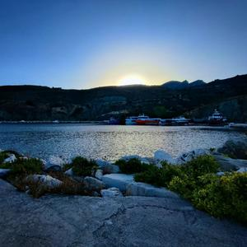

CHAPTER 2. PHOTOGRAPHS AND STORIES

85

2.0.1

Selection and Stories

Quiet reigns at the world’s edge. As you wait, the sun peeks over the horizon, half hidden. Its reflection dances on the water. Awe-inspiring, it easily mesmerizes.

This chance encounter, a magnificent view, reveals life’s true potential.

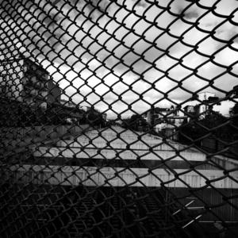

CHAPTER 2. PHOTOGRAPHS AND STORIES

86

Crossing the bridge, the restrictive view behind the fences unveils the city’s underbelly. This confined space evokes a sense of imprisonment, mirroring the feeling of being trapped in the materialistic world we often navigate. Yet, despite the constant presence of these negative experiences, we discover the resilience to carry on with life.

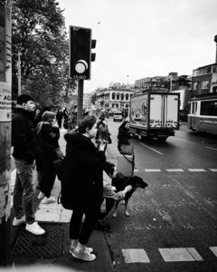

CHAPTER 2. PHOTOGRAPHS AND STORIES

87

Crossing the street is an essential part of daily life, but for this eager dog, it seems like an urgent mission.

As I waited patiently at the cross walk for the light to turn green, I observed the dog’s intense focus, its face sparkled with anticipation. It was clear that getting across quickly was of utmost importance to him.

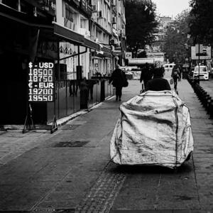

CHAPTER 2. PHOTOGRAPHS AND STORIES

88

It is possible to see such guy who carries the bag on the street. That should be heavier that we can reckon. In the other side, you see the value of money. It is ironic, innit?

Life of this guy is not valuable for most of us, but still it is a life, innit? Undeniable fact. we face the music.

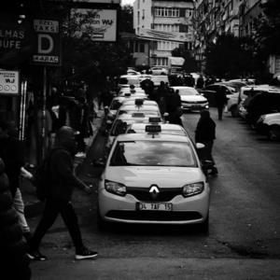

CHAPTER 2. PHOTOGRAPHS AND STORIES

89

Life unfolds around me: people stride by, taxis idle, and drivers wait, all caught in the ordinary rhythm of the day. Everything flows as it should. Yet, in a fleeting moment, I capture a glimpse of something special, a scene frozen in time. Two minutes pass, and the scene transforms, a reminder that these fleeting moments of life is everywhere, waiting to be discovered and captured.

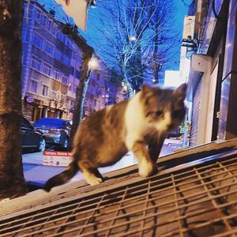

CHAPTER 2. PHOTOGRAPHS AND STORIES

90

As dawn approaches, a lonely cat wanders the streets with a sad expression. The city feels harsh and unforgiving. The small creature has little hope of finding a warm shelter at that hour. This harsh reality highlights the challenges of life in a city focused on material possessions. While the cat might survive, thriving in such an environment is far from guaranteed. Each tiny triumph evolves a spark of hope, like finding a comfortable place to rest.

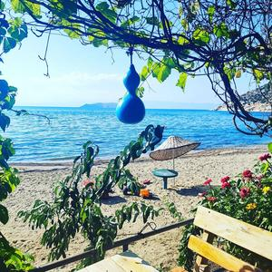

CHAPTER 2. PHOTOGRAPHS AND STORIES

91

Isn’t it time for a vacation? A peaceful and quiet spot awaits you at the edge of the world, offering sun, sea, sand, and so much more. Come and spend some time here; it’s worth it. You can even sleep under the stars—I personally vouch for it. I’ve been there myself, capturing the beauty in photos at dawn and dusk. Each moment holds its own secret treasure to discover. Everything you need to feed your soul is right here. So why not drop by sometime?



CHAPTER 2. PHOTOGRAPHS AND STORIES

92

What a marvellous view you experienced at that time of day. The sky was partially filled with yellow, and the other part was blue. It’s possible to see the same view reflected in the sea, inviting you to immerse yourself in its beauty.

Considering setting aside your busy, dusty life is one option; it just requires some courage for action. Seize this opportunity and adopt a new perspective, even if it doesn’t last long.

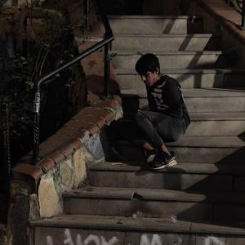

CHAPTER 2. PHOTOGRAPHS AND STORIES

93

A solitary figure on the street caught my eye. This scene prompted me to consider a closer examination. Beyond simply offering empathy to the individual, I felt compelled to assess the lighting conditions thoroughly for capturing the scene effectively. It’s crucial to portray the situation authentically and with a sense of wholeness.

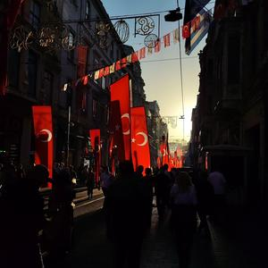

CHAPTER 2. PHOTOGRAPHS AND STORIES

94

We marched, a sea of flags dancing in the wind. Each one, a bright symbol of our nation, fluttered with pride.

It brought a feeling of deep connection, a sense of belonging to something bigger. This memory, forever etched in our hearts, reminds us of the powerful bond we share as a nation, united under the same symbol.

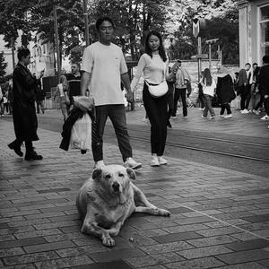

CHAPTER 2. PHOTOGRAPHS AND STORIES

95

Doggie stopped and sat, then smirked vaguely and mentioned instinctively, ’Woah, how did I end up here?

What is going on? What are those people jabbering about?’

Doggie was just curious. But it’s time for relaxation; I don’t really care what is happening around. Doggie may be sleepy, and people are marching down the street. That is how life flows. Nostalgic trains are on the way. Life is occupied with a lot of things such as people, nostalgic train building, and whatnot. Voices rise to the sky. The dog is just chilling, hanging, and staring



CHAPTER 2. PHOTOGRAPHS AND STORIES

96

The road ahead stretches on, each tire touching the earth.

Though our path is unclear, trees line the way. Inside the truck, the sounds are a mystery—maybe podcasts or silence with a companion. Romance might find us as we travel.

Life, like another bite of dust, unfolds along the road."

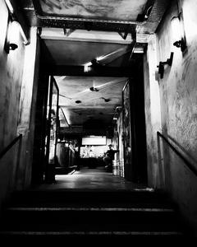

CHAPTER 2. PHOTOGRAPHS AND STORIES

97

Entrance of The place that we enjoy a lot. We are metal heads. We are shoulder crushers. We are waiting suitable time to go there. We are circling the head. We are following rhythm, feeling the emotion and burst into emotion. For someone, it is just exaggeration. For us, it is just entering a different word, more correctly phasing another dimension.

We are still us with something attached. It is hard to describe, you find that thing for yourself. It is a momentum thing. It still last until leaving this place.

Something incredible happen. Everyone should encounter that once in a life.



CHAPTER 2. PHOTOGRAPHS AND STORIES

98

You might imagine the cat has lost itself in sleep because of the comfort of the couch. Who knows how long their siesta will last? Apparently, they love to indulge in siestas just like us. Let’s observe this moment of pleasure with a relaxed attitude, without interrupting. Sometimes cats can compel you to delve into sleep too. Don’t watch them too closely, or you’ll find yourself falling for it.



CHAPTER 2. PHOTOGRAPHS AND STORIES

99

In the middle of nowhere, light seems alone and desperate.

However the light brighten the area regardless how big or small area is. It is inevitable truth, darkness has no power so as to sneak into place that light’s existence is obvious. As a matter of face, light will defeat darkness no matter what.

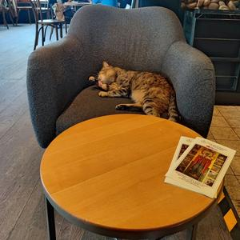

CHAPTER 2. PHOTOGRAPHS AND STORIES

100

Here’s another proof of the legitimacy of the previous photo. It’s a small couch, but I think that’s just fine. The cat is completely at peace, lost in its dreams. Let’s not disturb the moment. Instead, let it flow slowly, allowing time to deepen."

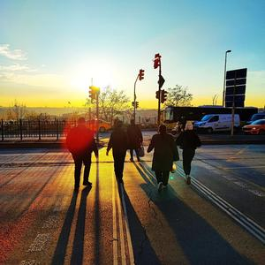

CHAPTER 2. PHOTOGRAPHS AND STORIES

101

Check the diversity in that photo. Colourful visual with some shadows that become visible in the evening time. It is just regular life with regular people crossing the street.

Colours you see are so special and precious. I am not sure those regular people were aware, but it is there with pure perfection.That perfection brings purification. Life is just so crystal Clear with colourful atmosphere. And we people are inside that clarity. We know all about atmosphere.

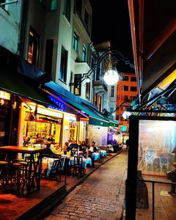

CHAPTER 2. PHOTOGRAPHS AND STORIES

102

This is the street we frequent, a pathway to a destination where unfolded moments of joy await us. Here, life bursts with laughter and shared experiences. Musicians delicately pluck strings and tap drums, filling the night air with the sweet sound of blues music. Passing through this street is our way of revisiting those unforgettable moments.

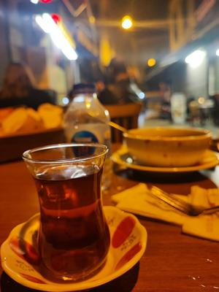

CHAPTER 2. PHOTOGRAPHS AND STORIES

103

It is the occasional metal night we did some handbag and smashing the soldier. The night brought some satisfactory if you smash the opponent. Don’t forget, is it just for joy.

The air thrums with a quiet victory. Time for a breather. So take some red blooded tea. A gentle breeze whispers peace, carrying snatches of heartfelt conversation. Sleep beckons cuz you are exhausted, but there’s a task yet unfinished -

You consider another cup. This moment, so sacred, deserves to be stretched as long as possible.

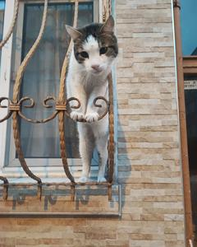

CHAPTER 2. PHOTOGRAPHS AND STORIES

104

A curious kitty sits on the windowsill, watching the world outside. Its paws rest gently on the edge, and its eyes sparkle with curiosity. It’s a peaceful scene of a cat enjoying the view.

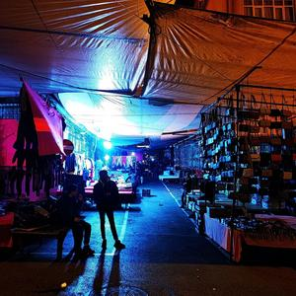

CHAPTER 2. PHOTOGRAPHS AND STORIES

105

Natural light had not yet dawned, but people were already bustling about, with preparations underway in anticipation of the imminent arrival of daylight. In a few hours, the sun would emerge, marking the beginning of a hectic day. Some would engage in vigorous work to sustain their livelihoods, while others would simply pass the time.

Those fortunate enough to stand out at night might earn some money. As the day draws to a close, a moment of chill settles in.

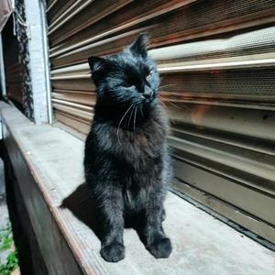

CHAPTER 2. PHOTOGRAPHS AND STORIES

106

On our way to a late-night jazz concert, we ran across a small, black cat in the middle of the road. The place we intended to reach was far away, we were practically sprinting to catch the show. But this adorable kitty locked eyes with us, its gaze demanding our attention.

We couldn’t resist giving it a good scratch and enjoying the feel of its soft fur. Though a slight detour, the encounter warmed our hearts. And We reached the concert safe and sound, but the music was fantastic. Sometimes, the best experiences come from unexpected detours.

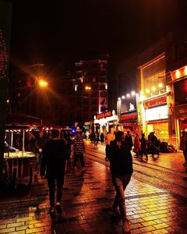

CHAPTER 2. PHOTOGRAPHS AND STORIES

107

This unfiltered photo captures the energy of Istanbul’s Istiklal Street on a rainy day. Raindrops dance on the cobblestones, and the city’s spirit shines through, even on a damp day.

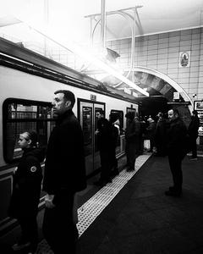

CHAPTER 2. PHOTOGRAPHS AND STORIES

108

This black and white photo takes us back in time. A vintage train, shiny and elegant, stands ready. People in fancy clothes board and disembark, creating a scene straight out of the past. It makes you wonder about the journeys they took and where they were going.

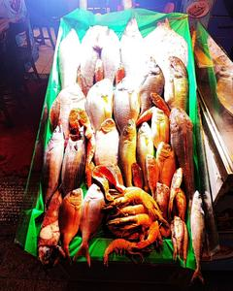

CHAPTER 2. PHOTOGRAPHS AND STORIES

109

Colourful fish, arranged neatly on a plate, catch your eye as much as they tempt your taste buds. The way they are placed creates a pretty design, making them a delicious treat that’s pleasing to the senses.

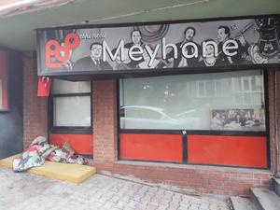

CHAPTER 2. PHOTOGRAPHS AND STORIES

110

These were the habits of old times. People would go there and reach the maximum level of joy, accompanied by classical rakı, fish, and snacks. If there was good music, the time you spent there became a cherished memory. Nothing can replace that moment. Indeed, it was legitimate for someone who had a certain style.

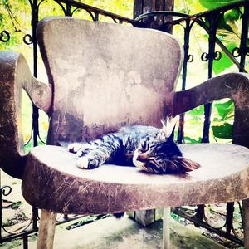

CHAPTER 2. PHOTOGRAPHS AND STORIES

111

The cat is peacefully sleeping, the chair remains still amidst nature’s tranquillity. The gentle breeze flows, and light spreads around with equilibrium. What more could a sleepy cat desire? This is the perfect time and spot for a nap.

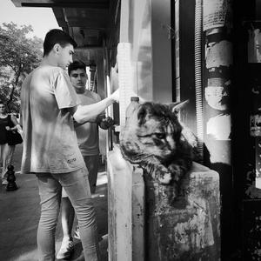

CHAPTER 2. PHOTOGRAPHS AND STORIES

112

The person withdrawing money and the cat just chilling there should be proof that we belong to different worlds.

Interestingly, both are not happy just spending time for nothing. Actually, the cat likes to chill, but this feeling wishes for something more. Unfortunately, that doesn’t likely happen here. But still, seize the moments and lay down.

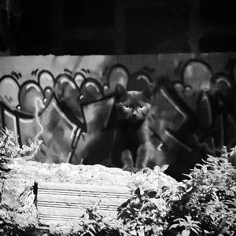

CHAPTER 2. PHOTOGRAPHS AND STORIES

113

Cat is so cute. Its black fur mesmerizes us in that enlightened environment. The cat just checks you with shyness a little bit. Checking the entirety of the environment brings you the feeling that the cat is a nice part of that pose with its emotions. All of that can be mentioned instinctively, revealing itself by a simple check.

Just spare a little time."

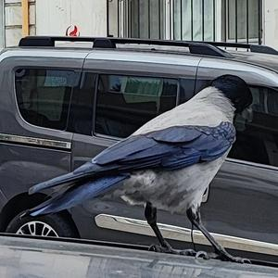

CHAPTER 2. PHOTOGRAPHS AND STORIES

114

The photographer recalls a lucky moment, capturing a stunning bird up close. Every feather, every detail, was a sight to behold. With a touch of British humour, they couldn’t help but think, "Suits you sir!" – the bird was perfectly at home in its beautiful surroundings.

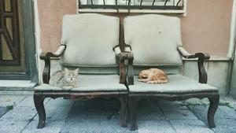

CHAPTER 2. PHOTOGRAPHS AND STORIES

115

Cats are the masters of relaxation. They can curl up on any cosy spot, like their favourite couch, and spend hours just chilling out. You can tell they’re truly enjoying themselves, watching the world go by with calm, curious eyes. It’s tempting to join them and share in their peaceful moment, but for now, it’s their time to unwind.

Maybe someday I’ll find my own perfect spot to relax just like them.

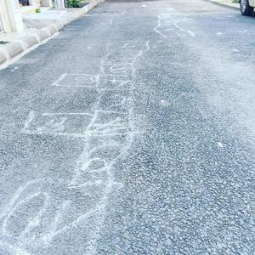

CHAPTER 2. PHOTOGRAPHS AND STORIES

116

This simple game from our childhood brings back so many happy memories. We’d toss a rock, then follow its path, step by joyful step, sometimes even adding a bit of adventurous acrobatics. It was pure joy. Sharing the story might not recapture that feeling, but the photo serves as a reminder of the hidden gems buried in our memories, the simple joys that continue to bring a smile, even if they’re tucked away beneath the surface.

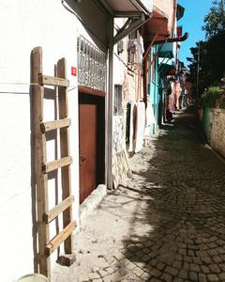

CHAPTER 2. PHOTOGRAPHS AND STORIES

117

This small part of the city stands apart from the monotonous rhythm of urban life. Here, something different happens. People live in harmony, finding meaning in everyday objects like the ladder that holds sentimental value for many. Everything here carries significance. While the saying goes, ’big swallow small,’

sometimes, it’s the small moments that endow life with a sense of purpose and meaning.

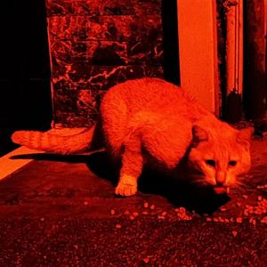

CHAPTER 2. PHOTOGRAPHS AND STORIES

118

A red-colored feline exhibits a unique personality. The interpretation of its expression suggests that it is the cult of personality. It is the underdog around here. Is there someone daring to mess with me? I don’t think so.

I am angry, pissed off, and the judge of the night. You will taste my judgment. You should try not to cross paths with me. Otherwise, you are in trouble.

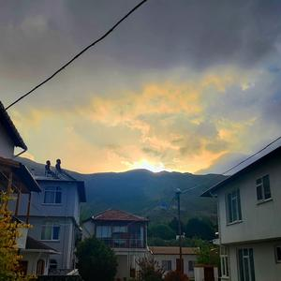

CHAPTER 2. PHOTOGRAPHS AND STORIES

119

Living in a small town is truly a unique experience. The pace of life is slower, allowing you to feel the passage of time in your veins. Discovering the treasures hidden within its streets, you realize the importance of cherishing them. Take a moment to breathe and marvel at the beauty surrounding you. Sometimes, it’s essential to escape there, to immerse yourself in the local way of life.

Whether it’s selling tomatoes, feeding animals, or simply being part of the community, embracing the idea of being a local brings a sense of purity and contentment.



CHAPTER 2. PHOTOGRAPHS AND STORIES

120

In the midst of the sea, the boat appeared unoccupied, basking in the sun’s orange glow reflected off the calm waves. Yet, there was a sense that someone lay asleep on board, perhaps waiting for the opportune moment to fish or simply savouring the tranquil atmosphere. The conditions seemed perfect, but one couldn’t help but wonder what the upcoming hours held in store, as the serenity of the scene hinted at potential surprises yet to unfold.

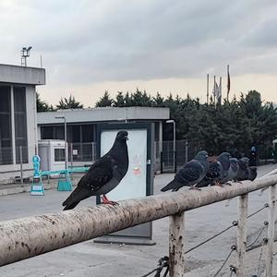

CHAPTER 2. PHOTOGRAPHS AND STORIES

121

The pigeons were perched in a neat row, their leader clearly distinguished by its posture. The others remained seated, while the leader stood tall and alert. Perhaps it was a family gathering, or maybe a crucial meeting was underway. Agility didn’t seem to be their primary concern at the moment; they were more focused on observing their surroundings. People rush by, not even seeing the crows.

Maybe they should stop and look around. This world isn’t just for us, it’s for them too. We build so much stuff, but where do the birds go?



122

Chapter 3

Categoric Selections

Life has a way of rushing by, but amidst the chaos, I’ve learned to pause and cherish the quiet moments. With my camera in hand, I capture the beauty that o ften goes unnoticed in the hustle and bustle of everyday life. Whether it’s the gentle play of sunlight on weathered walls or the resilience of a single flower breaking through concrete, these whispers of beauty speak volumes to me.

This book is a collection of those whispers, a visual diary of my journey exploring [theme]. Each photograph holds a story, a moment frozen in time, waiting to be shared and cherished.

As you turn the pages, I invite you to step into these scenes and experience them with all your senses. Let these photos serve as inspiration to find magic in the ordinary and to capture the stories that touch your soul.

a b

a In categoric selection, I try to choose thematic photo. Some can be close to other. I try to create diversity.

b In the experimental category, I try to push limits a little bit. I try to manipulate so different perspective can change the environment of poses.

CHAPTER 3. CATEGORIC SELECTIONS

123

This version uses shorter sentences that contain some rhymes within. While preserving the essence of the potential long version.

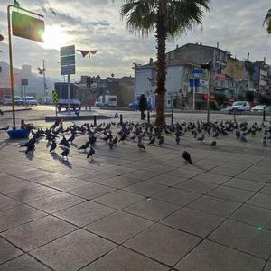

CHAPTER 3. CATEGORIC SELECTIONS

124

3.1

Categories

3.1.1

City

Several birds in city centre

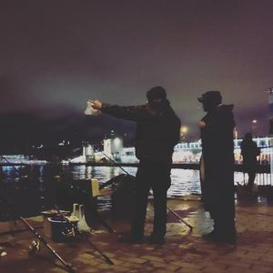

CHAPTER 3. CATEGORIC SELECTIONS

125

Haunter guys



CHAPTER 3. CATEGORIC SELECTIONS

126

Supporters and flags.

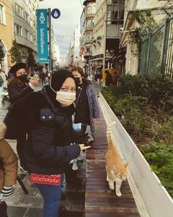

CHAPTER 3. CATEGORIC SELECTIONS

127

Fabulous cats are always in the middle of interest

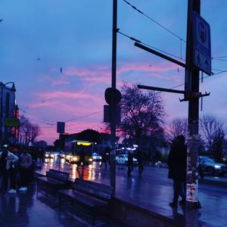

CHAPTER 3. CATEGORIC SELECTIONS

128

Evening blue is captivating and dominating.

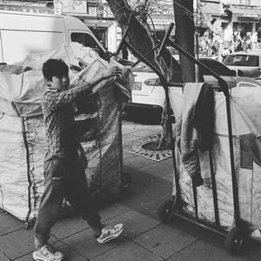

CHAPTER 3. CATEGORIC SELECTIONS

129

Life is tough.

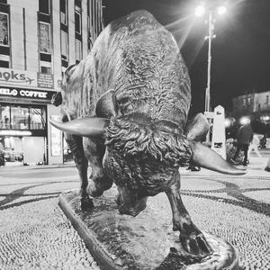

CHAPTER 3. CATEGORIC SELECTIONS

130

The symbol, the power.

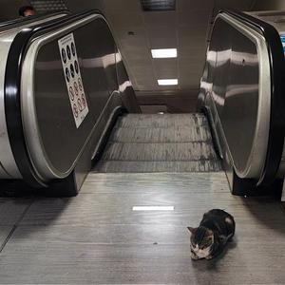

CHAPTER 3. CATEGORIC SELECTIONS

131

Cats are everywhere.



CHAPTER 3. CATEGORIC SELECTIONS

132

3.1.2

Saturated

Resplendent source has great reflection on the surface.

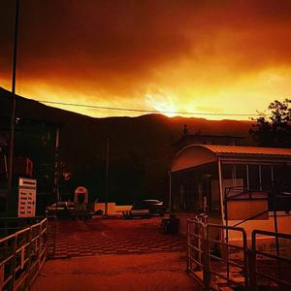

CHAPTER 3. CATEGORIC SELECTIONS

133

All things are effected with burning effect.

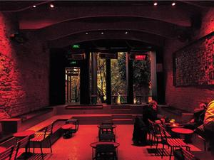

CHAPTER 3. CATEGORIC SELECTIONS

134

Dominance of red make a dent.



CHAPTER 3. CATEGORIC SELECTIONS

135

Sky is red, leafs are black, fail in love great.

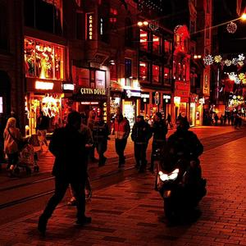

CHAPTER 3. CATEGORIC SELECTIONS

136

Street is crowded. People are fast. Transposers all of them.

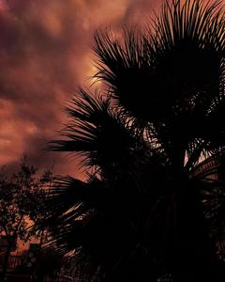

CHAPTER 3. CATEGORIC SELECTIONS

137

Different tones of black and red. Harmonizing together neat.



CHAPTER 3. CATEGORIC SELECTIONS

138

Going to infinity, sun is waiting, Window show its way.

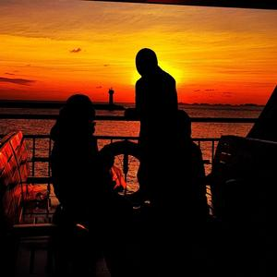

CHAPTER 3. CATEGORIC SELECTIONS

139

Something happened so true. And it is awesome.

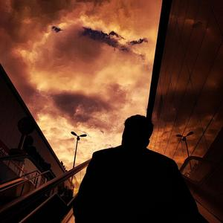

CHAPTER 3. CATEGORIC SELECTIONS

140

Checking sky, cloudy weather. Do we really see what is coming?

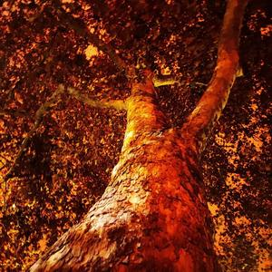

CHAPTER 3. CATEGORIC SELECTIONS

141

Burning tree with great texture.

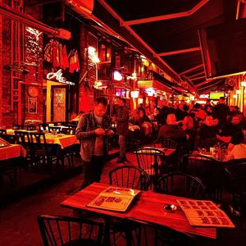

CHAPTER 3. CATEGORIC SELECTIONS

142

Time to spice up the PLACE !!!

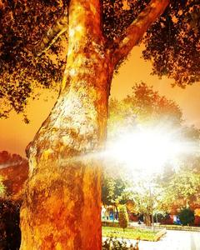

CHAPTER 3. CATEGORIC SELECTIONS

143

See the texture how it is manipulated with resplendent light.

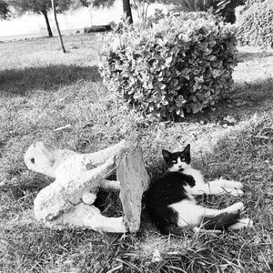

CHAPTER 3. CATEGORIC SELECTIONS

144

3.1.3

B-W

Alignment happened well.

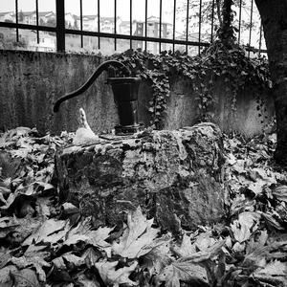

CHAPTER 3. CATEGORIC SELECTIONS

145

Pull the water. Requires some strength.

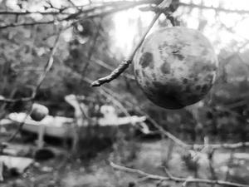

CHAPTER 3. CATEGORIC SELECTIONS

146

Fruit and blurry background.

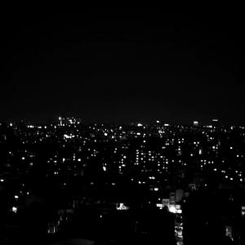

CHAPTER 3. CATEGORIC SELECTIONS

147

Those are not points but city lights.

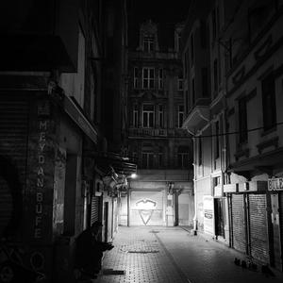

CHAPTER 3. CATEGORIC SELECTIONS

148

Lonely man in darkness.

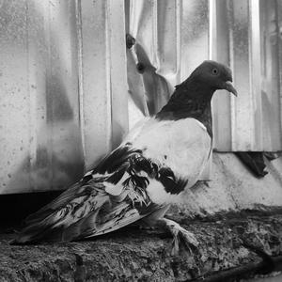

CHAPTER 3. CATEGORIC SELECTIONS

149

Read the emotion of birdie..

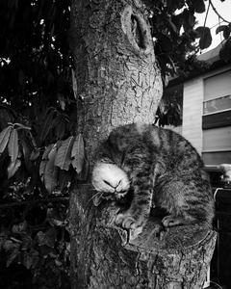

CHAPTER 3. CATEGORIC SELECTIONS

150

Cat is so chill.

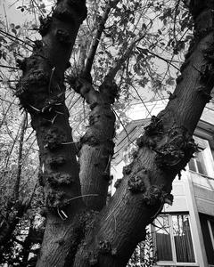

CHAPTER 3. CATEGORIC SELECTIONS

151

Something happened to tree.

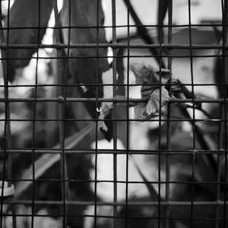

CHAPTER 3. CATEGORIC SELECTIONS

152

Nature is so alone. Invasion of reckless.

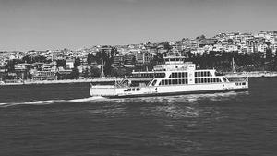

CHAPTER 3. CATEGORIC SELECTIONS

153

Just city.

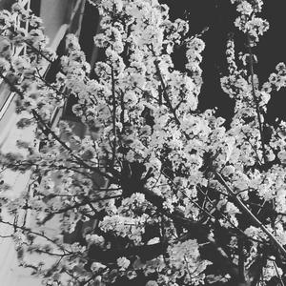

CHAPTER 3. CATEGORIC SELECTIONS

154

Lots of flowers over there.

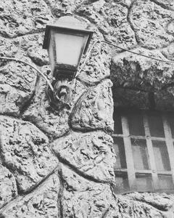

CHAPTER 3. CATEGORIC SELECTIONS

155

Wholeheartedly fancy.

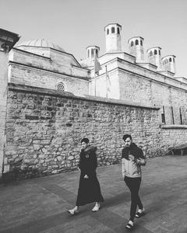

CHAPTER 3. CATEGORIC SELECTIONS

156

It was like taken from middle-age in B-W form. Well sorta.

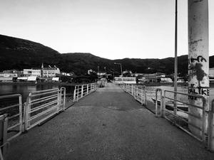

CHAPTER 3. CATEGORIC SELECTIONS

157

Small town, small life liveable place. What else you want..

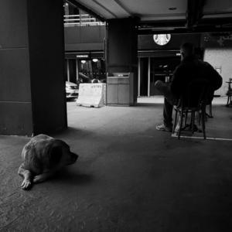

CHAPTER 3. CATEGORIC SELECTIONS

158

Not friend, not something in common. Still staring each other.

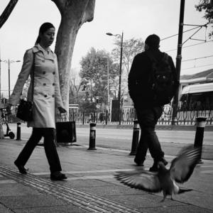

CHAPTER 3. CATEGORIC SELECTIONS

159

Birdie is awesome. And only awesome thing in that life scene.

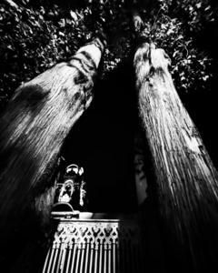

CHAPTER 3. CATEGORIC SELECTIONS

160

So artistic and classy from certain angle really.



CHAPTER 3. CATEGORIC SELECTIONS

161

Ready for crossing street. The dog and the peeps.

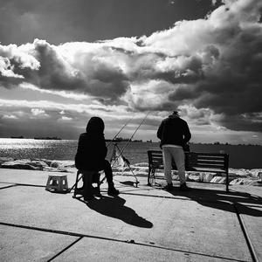

CHAPTER 3. CATEGORIC SELECTIONS

162

Really calming fellow gathered for fishing..

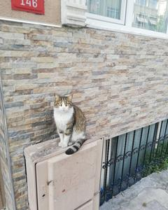

CHAPTER 3. CATEGORIC SELECTIONS

163

3.1.4

Animal

That feline is so happy.

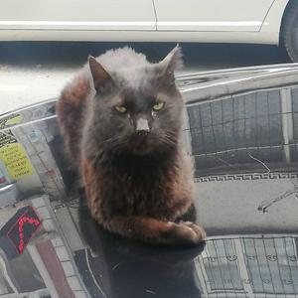

CHAPTER 3. CATEGORIC SELECTIONS

164

Whereas this feline seems kinda pissed.

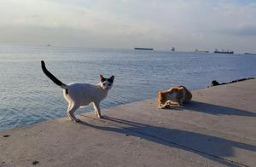

CHAPTER 3. CATEGORIC SELECTIONS

165

Independent, yet contributing. Each plays its part.

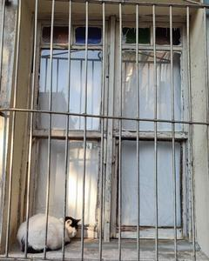

CHAPTER 3. CATEGORIC SELECTIONS

166

Weathered shelter, feline haven.

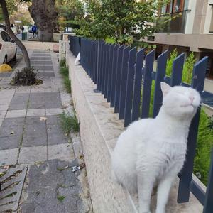

CHAPTER 3. CATEGORIC SELECTIONS

167

It is just interesting innit?



CHAPTER 3. CATEGORIC SELECTIONS

168

It is middle of night, so lonely and quietly. THE CAT



CHAPTER 3. CATEGORIC SELECTIONS

169

Shelter is so close, let me sneak into it.

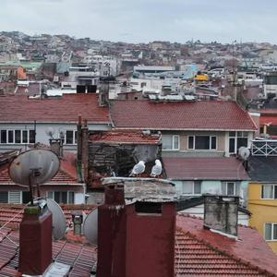

CHAPTER 3. CATEGORIC SELECTIONS

170

We are at the top almost at the sky. Lets open our wings.

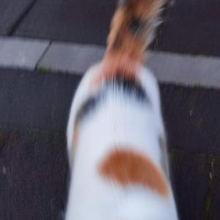

CHAPTER 3. CATEGORIC SELECTIONS

171

Blurry fur. So fortunate.

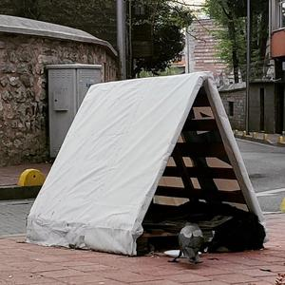

CHAPTER 3. CATEGORIC SELECTIONS

172

Big and secure. There must be a room for me.

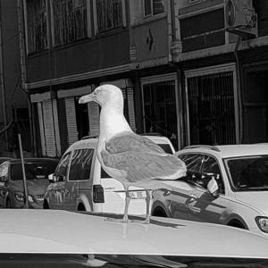

CHAPTER 3. CATEGORIC SELECTIONS

173

Black and white make it visual more characteristic sometimes.

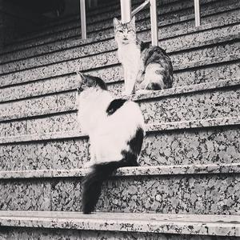

CHAPTER 3. CATEGORIC SELECTIONS

174

One of cat stared diligently.

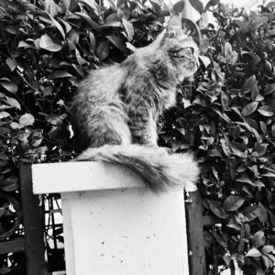

CHAPTER 3. CATEGORIC SELECTIONS

175

Life is so moving.

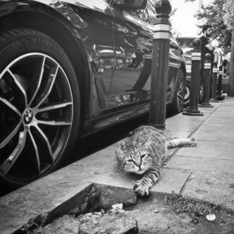

CHAPTER 3. CATEGORIC SELECTIONS

176

Just resting a bit. Don’t touch me.

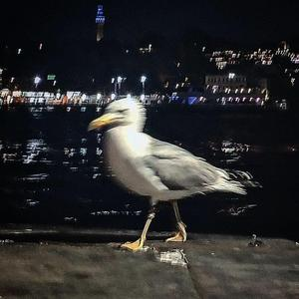

CHAPTER 3. CATEGORIC SELECTIONS

177

Still seagull but kinda vague.

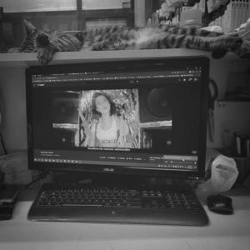

CHAPTER 3. CATEGORIC SELECTIONS

178

Just check screen. Don’t think about ruining my moment.

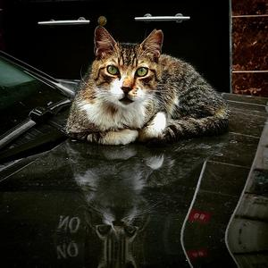

CHAPTER 3. CATEGORIC SELECTIONS

179

What is more attractive. My reflection or my eyes.

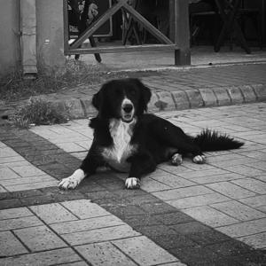

CHAPTER 3. CATEGORIC SELECTIONS

180

I am so chill, let’s leave it like that.

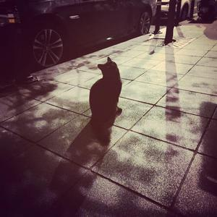

CHAPTER 3. CATEGORIC SELECTIONS

181

Colourful or colorless. I am at the middle of somewhere.

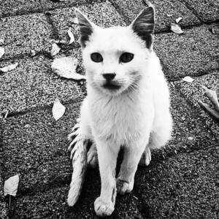

CHAPTER 3. CATEGORIC SELECTIONS

182

As mentioned above black and white make visual more characteristic you can read on its face.

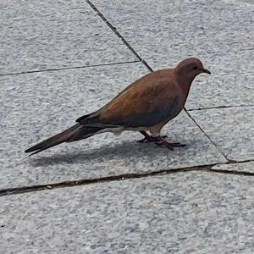

CHAPTER 3. CATEGORIC SELECTIONS

183

Just a life like other really important life. We are all regular.

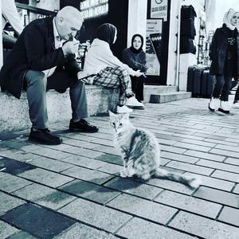

CHAPTER 3. CATEGORIC SELECTIONS

184

Different colour theme gain visual some personality. It can be cult of personality.

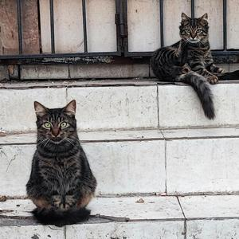

CHAPTER 3. CATEGORIC SELECTIONS

185

Close but really. It is amazingly drawn by GOD? Who knows?

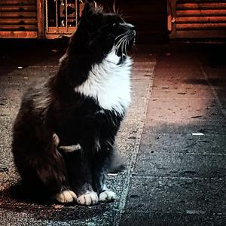

CHAPTER 3. CATEGORIC SELECTIONS

186

I am king. Bring my crown.

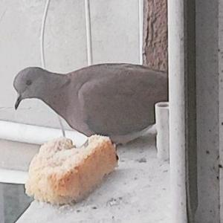

CHAPTER 3. CATEGORIC SELECTIONS

187

C’est la vie. Life is here, I am there. Bread is nice addition for my life.

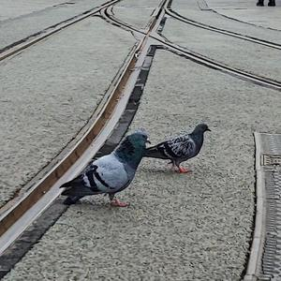

CHAPTER 3. CATEGORIC SELECTIONS

188

Road is crossing, Pigeons are walking.

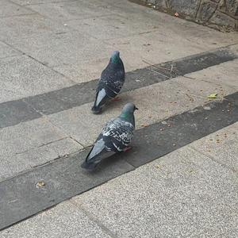

CHAPTER 3. CATEGORIC SELECTIONS

189

Colour varies. Same species.

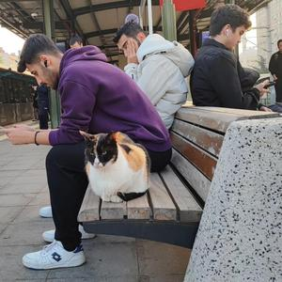

CHAPTER 3. CATEGORIC SELECTIONS

190

Harmonious coexistence.

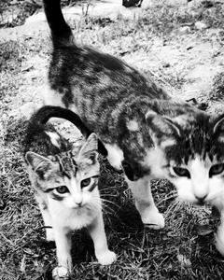

CHAPTER 3. CATEGORIC SELECTIONS

191

The fabulous creature’s cuteness shines through undeniably.



CHAPTER 3. CATEGORIC SELECTIONS

192

Tiny wonders live close by. We just need to look closer.

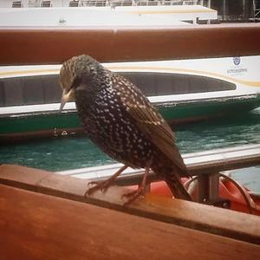

CHAPTER 3. CATEGORIC SELECTIONS

193

Bird came here to stay a little longer.

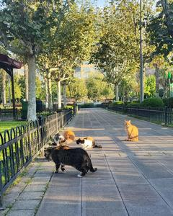

CHAPTER 3. CATEGORIC SELECTIONS

194

They are mingling.

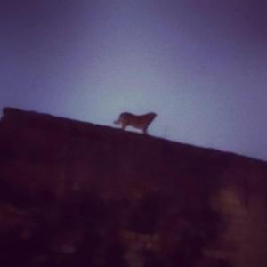

CHAPTER 3. CATEGORIC SELECTIONS

195

Doggie is gone AWOL.

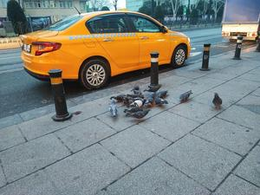

CHAPTER 3. CATEGORIC SELECTIONS

196

Birds gathered for certain action.

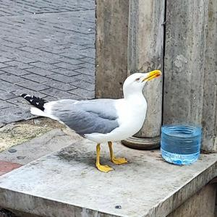

CHAPTER 3. CATEGORIC SELECTIONS

197

Seagull, just satisfied momentarily.

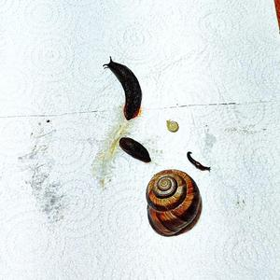

CHAPTER 3. CATEGORIC SELECTIONS

198

It is all the same. Ya know.

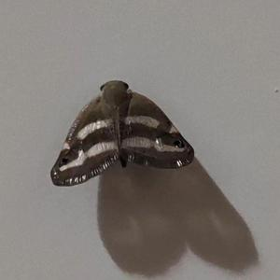

CHAPTER 3. CATEGORIC SELECTIONS

199

Small but not ignorable. Awesomeness is there.

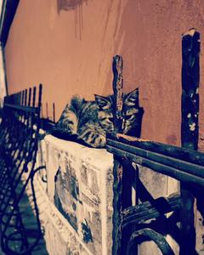

CHAPTER 3. CATEGORIC SELECTIONS

200

So wasted but emotional kitties.

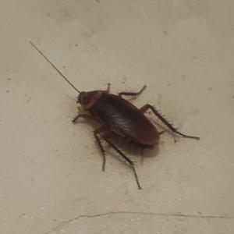

CHAPTER 3. CATEGORIC SELECTIONS

201

Let me introduce myself, I am The Insect.

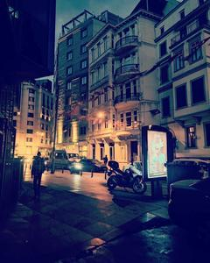

CHAPTER 3. CATEGORIC SELECTIONS

202

3.1.5

Experimental

Ordinary night colourful sight.

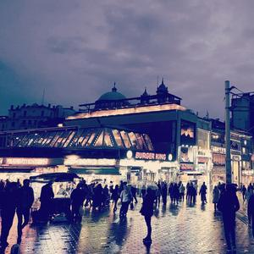

CHAPTER 3. CATEGORIC SELECTIONS

203

Colours dance, secrets unfold.

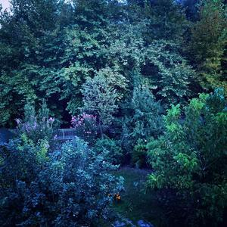

CHAPTER 3. CATEGORIC SELECTIONS

204

Secrets unfold their beauty as a timeless story.



CHAPTER 3. CATEGORIC SELECTIONS

205

This is also part of life, just your hand grab.

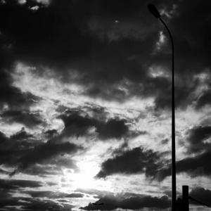

CHAPTER 3. CATEGORIC SELECTIONS

206

Darkness and light works together. time to reveal greatness

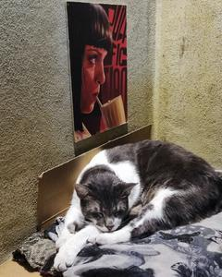

CHAPTER 3. CATEGORIC SELECTIONS

207

Comfy place for a cat by all means.

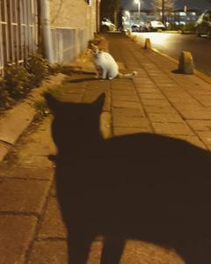

CHAPTER 3. CATEGORIC SELECTIONS

208

Constant starring.

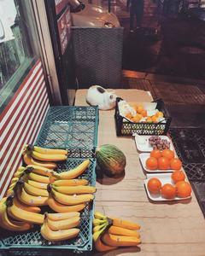

CHAPTER 3. CATEGORIC SELECTIONS

209

Cat sleep even though lots of yummy things around.

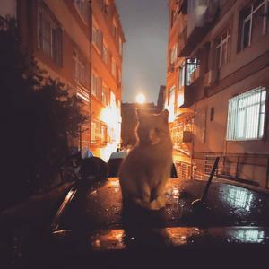

CHAPTER 3. CATEGORIC SELECTIONS

210

Cat in the middle of the night.



CHAPTER 3. CATEGORIC SELECTIONS

211

Delicious ice cream, waiting for you.



CHAPTER 3. CATEGORIC SELECTIONS

212

Empty street, sun and sea. Place for wonderer.



CHAPTER 3. CATEGORIC SELECTIONS

213

Loving cars, demanding cars. Must be vintage one.

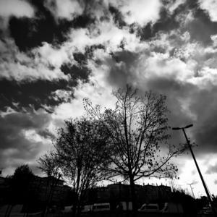

CHAPTER 3. CATEGORIC SELECTIONS

214

Marvellous trees grasp your eyes in dark theme..

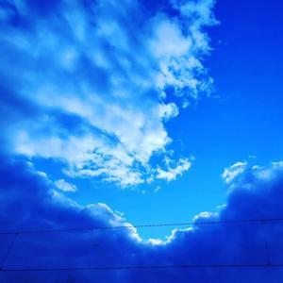

CHAPTER 3. CATEGORIC SELECTIONS

215

Endless blue sky, a breathtaking canvas above.

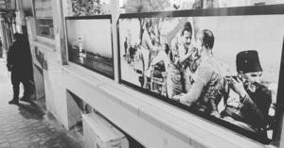

CHAPTER 3. CATEGORIC SELECTIONS

216

Just random photo from city.

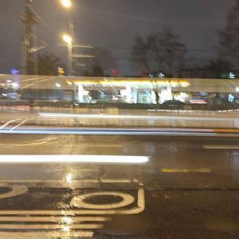

CHAPTER 3. CATEGORIC SELECTIONS

217

Light manipulation is all around. Just wait and see.

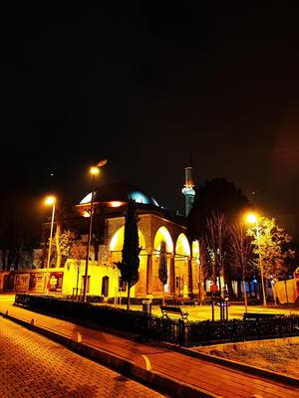

CHAPTER 3. CATEGORIC SELECTIONS

218

Beauty of Architecture is more obvious at night.

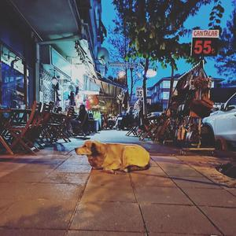

CHAPTER 3. CATEGORIC SELECTIONS

219

City lights dance, Dog finds peace.

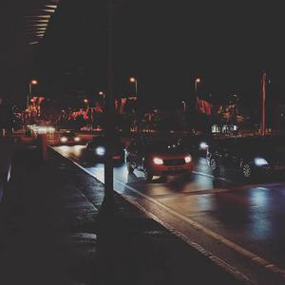

CHAPTER 3. CATEGORIC SELECTIONS

220

Stuck in molasses. Infuriating.

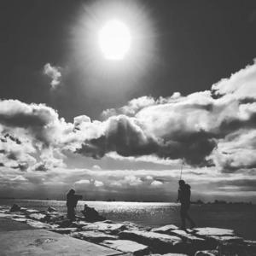

CHAPTER 3. CATEGORIC SELECTIONS

221

Two men, confident, stand beneath sun and clouds.

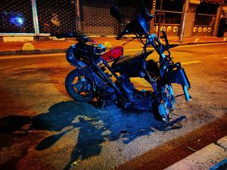

CHAPTER 3. CATEGORIC SELECTIONS

222

Wrecked motorcycle in the middle of the night. Like a collector, collect the parts.

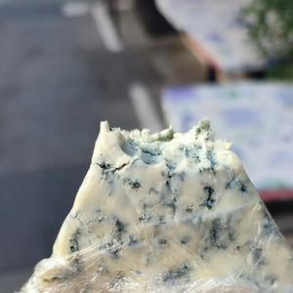

CHAPTER 3. CATEGORIC SELECTIONS

223

Favourite cheese. ROQUEFORT.

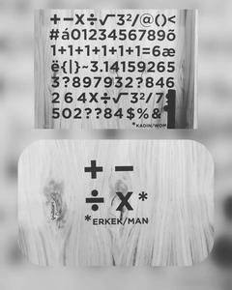

CHAPTER 3. CATEGORIC SELECTIONS

224

Puzzle and hidden message inside. Waiting for decipher.

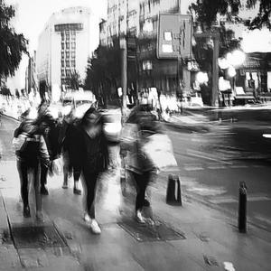

CHAPTER 3. CATEGORIC SELECTIONS

225

Everything is vague here still grokkable nevertheless.

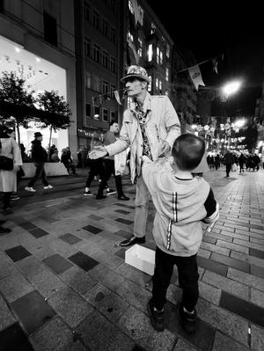

CHAPTER 3. CATEGORIC SELECTIONS

226

Man stands child plays. Man does some face while kid enjoy.

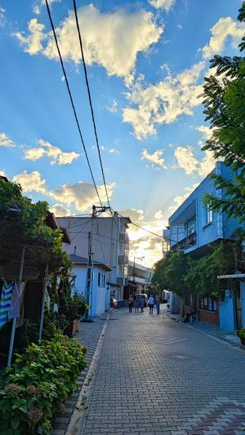

CHAPTER 3. CATEGORIC SELECTIONS

227

Good spot for chilling out. Sky take its time to shape nice.

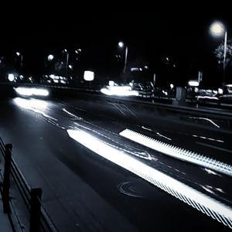

CHAPTER 3. CATEGORIC SELECTIONS

228

Through light we live, then fade to endless night.

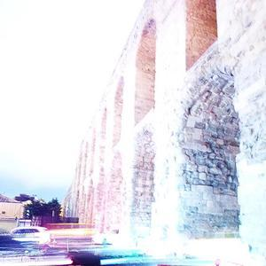

CHAPTER 3. CATEGORIC SELECTIONS

229

Landscape inspires. A reason for everything.

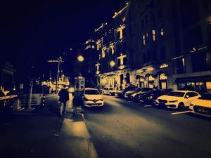

CHAPTER 3. CATEGORIC SELECTIONS

230

Different colours, different meaning still get the idea of life.

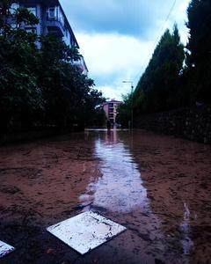

CHAPTER 3. CATEGORIC SELECTIONS

231

Nature: powerful teacher, harsh judge.

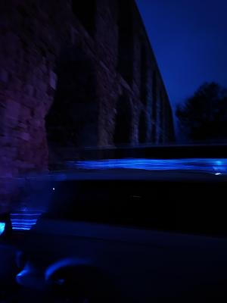

CHAPTER 3. CATEGORIC SELECTIONS

232

It is like two sides of coin at the night. First side

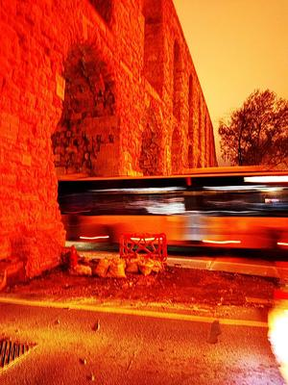

CHAPTER 3. CATEGORIC SELECTIONS

233

It is like two sides of coin at the night. Second side

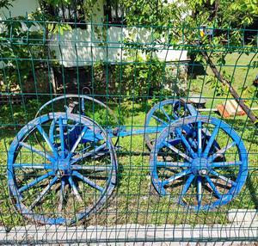

CHAPTER 3. CATEGORIC SELECTIONS

234

Oldies but goldies. Reminder of old times.

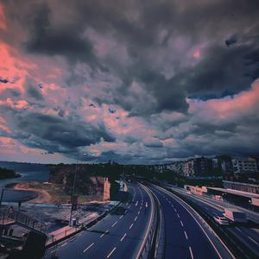

CHAPTER 3. CATEGORIC SELECTIONS

235

Vast landscape. Haunting silence.

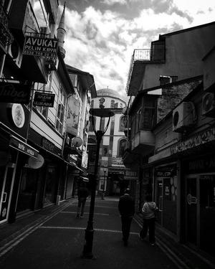

CHAPTER 3. CATEGORIC SELECTIONS

236

A landscape from small city BARTIN

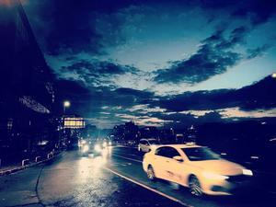

CHAPTER 3. CATEGORIC SELECTIONS

237

Really deep scene with colors of life.

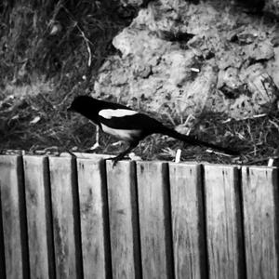

CHAPTER 3. CATEGORIC SELECTIONS

238

One of smartest fella magpie with other species like Crows, Ravens, Jays

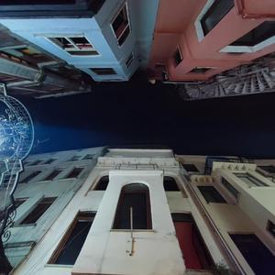

CHAPTER 3. CATEGORIC SELECTIONS

239

Yes, "Looking up, you see the world in a whole new light.

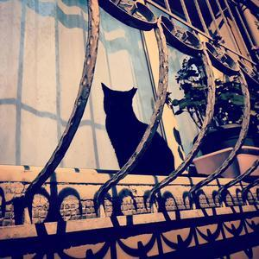

CHAPTER 3. CATEGORIC SELECTIONS

240

Sharp silhouette, curiosity hides in plain sight.



241

Chapter 4

Special Selections

Imagine stepping into a world where creativity knows no bounds and every click of the camera unleashes a wave of possibilities. That’s the world of experimental photography—a place where artists defy the rules, embrace imperfections, and dance on the edge of imagination.

In this book, we’ll take you on a journey through the heart of experimental photography, where passion meets innovation and every image tells a story. You’ll meet artists who dare to challenge conventions, exploring new techniques and push-ing the boundaries of visual storytelling.

As you flip through these pages, you’ll discover the magic of experimental techniques—like double exposures, collage, and digital manipulation—that transform ordinary scenes into ex-traordinary works of art. You’ll see how these techniques breathe life into images, adding layers of meaning and depth that challenge the way we see the world.

CHAPTER 4. SPECIAL SELECTIONS

242

But experimental photography is about more than just technique—it’s about embracing the unexpected and finding beauty in the chaos. It’s about letting go of control and allowing the creative process to unfold naturally, leading to moments of serendipity that spark inspiration and ignite the imagination.

Through the stories of photographers who have dared to dream, you’ll gain insight into the soul of experimental photography. You’ll see how it’s not just about capturing moments, but about capturing emotions and ideas that transcend the limits of the lens.

And as you journey through these pages, you’ll come to understand that experimental photography isn’t just a hobby or a profession—it’s a way of seeing the world. It’s about finding beauty in the unexpected, embracing imperfections, and celebrating the joy of creation.

So join us as we explore the wild, wonderful world of experimental photography. Let’s push the boundaries, defy expectations, and see where the journey takes us. After all, in the world of experimental photography, the only limit is your imagination.

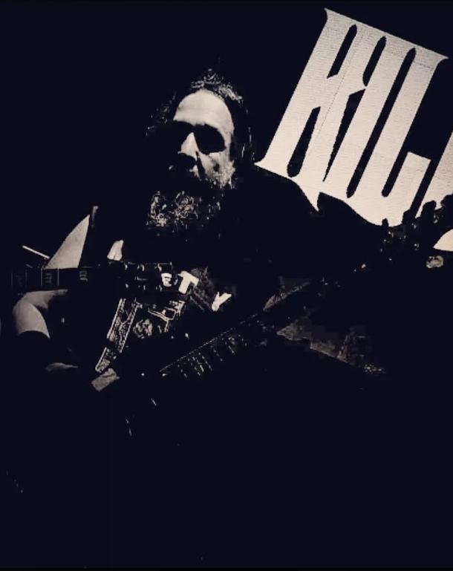

CHAPTER 4. SPECIAL SELECTIONS

243

4.0.1

Honorable Mention

a

a Some kind of monster this monster lives..



CHAPTER 4. SPECIAL SELECTIONS

244

4.0.2

All Speciality

a

a We always there to put our back into the oar.

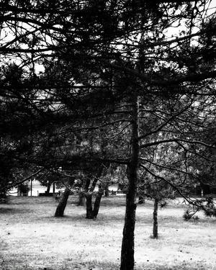

CHAPTER 4. SPECIAL SELECTIONS

245

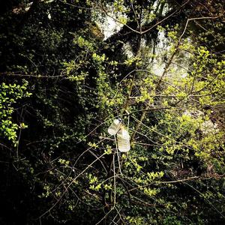

CHAPTER 4. SPECIAL SELECTIONS

246

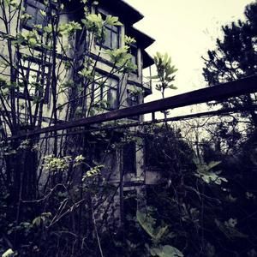

CHAPTER 4. SPECIAL SELECTIONS

247

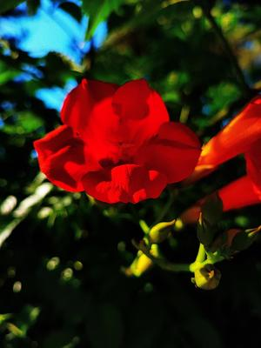

CHAPTER 4. SPECIAL SELECTIONS

248

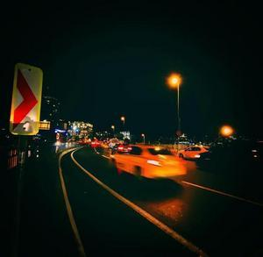

CHAPTER 4. SPECIAL SELECTIONS

249



CHAPTER 4. SPECIAL SELECTIONS

250

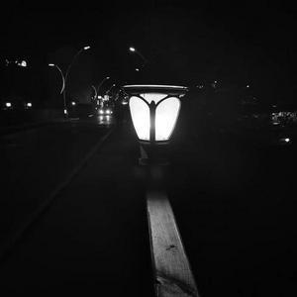

CHAPTER 4. SPECIAL SELECTIONS

251

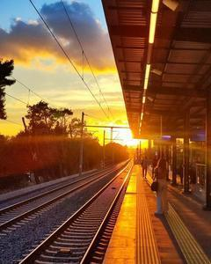

CHAPTER 4. SPECIAL SELECTIONS

252

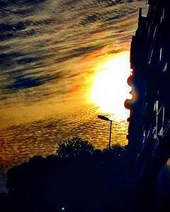

CHAPTER 4. SPECIAL SELECTIONS

253

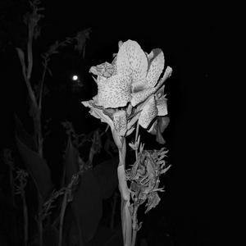

CHAPTER 4. SPECIAL SELECTIONS

254



CHAPTER 4. SPECIAL SELECTIONS

255

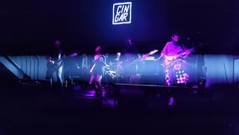

CHAPTER 4. SPECIAL SELECTIONS

256

a

a Colors and music really fits together.



CHAPTER 4. SPECIAL SELECTIONS

257

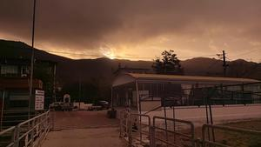

CHAPTER 4. SPECIAL SELECTIONS

258

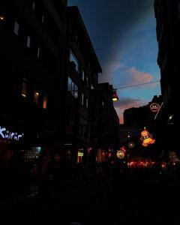

CHAPTER 4. SPECIAL SELECTIONS

259

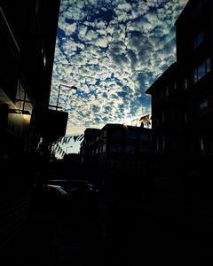

CHAPTER 4. SPECIAL SELECTIONS

260

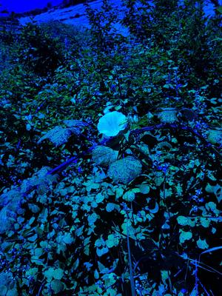

CHAPTER 4. SPECIAL SELECTIONS

261

a

a Beauty in nature is trumendeous.

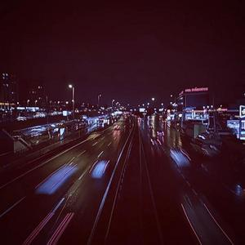

CHAPTER 4. SPECIAL SELECTIONS

262

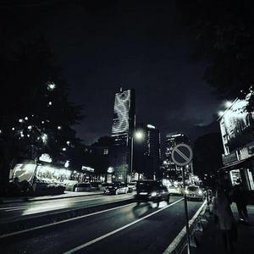

CHAPTER 4. SPECIAL SELECTIONS

263

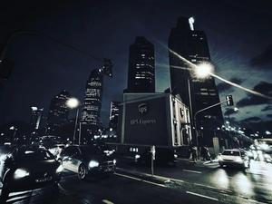

CHAPTER 4. SPECIAL SELECTIONS

264



CHAPTER 4. SPECIAL SELECTIONS

265

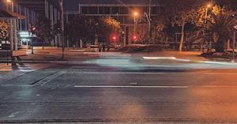

CHAPTER 4. SPECIAL SELECTIONS

266

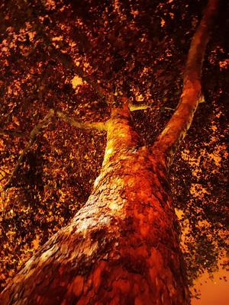

CHAPTER 4. SPECIAL SELECTIONS

267

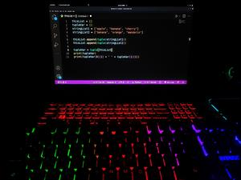

CHAPTER 4. SPECIAL SELECTIONS

268

a

a ifelseswitchwhilecase => 101000100011110110111101111

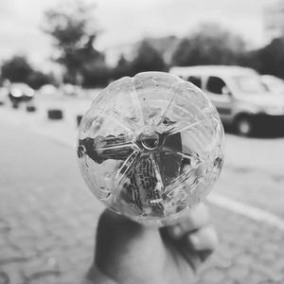

CHAPTER 4. SPECIAL SELECTIONS

269

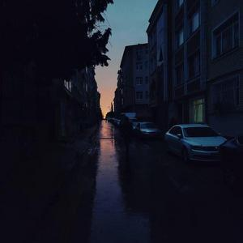

CHAPTER 4. SPECIAL SELECTIONS

270

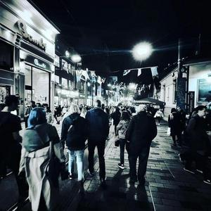

CHAPTER 4. SPECIAL SELECTIONS

271

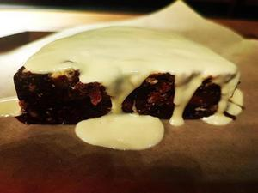

CHAPTER 4. SPECIAL SELECTIONS

272

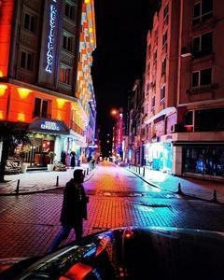

CHAPTER 4. SPECIAL SELECTIONS

273

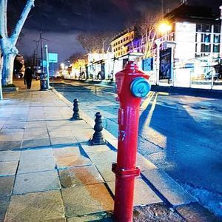

CHAPTER 4. SPECIAL SELECTIONS

274

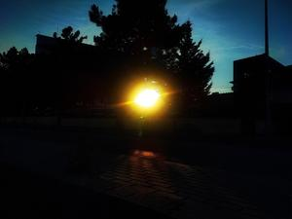

CHAPTER 4. SPECIAL SELECTIONS

275

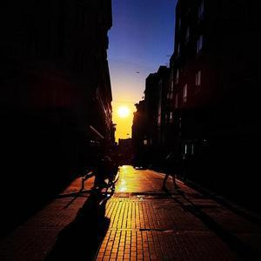

CHAPTER 4. SPECIAL SELECTIONS

276

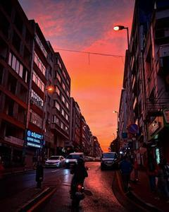

CHAPTER 4. SPECIAL SELECTIONS

277

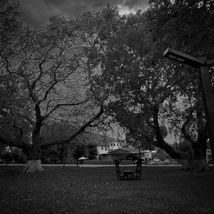

CHAPTER 4. SPECIAL SELECTIONS

278



CHAPTER 4. SPECIAL SELECTIONS

279

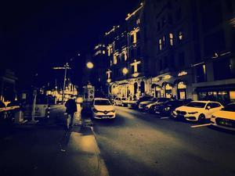

CHAPTER 4. SPECIAL SELECTIONS

280

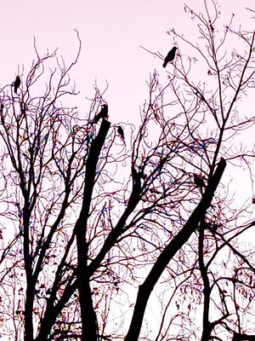

CHAPTER 4. SPECIAL SELECTIONS

281

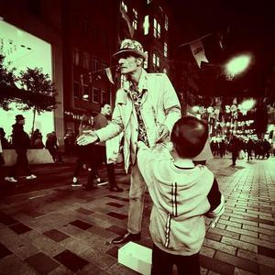

CHAPTER 4. SPECIAL SELECTIONS

282

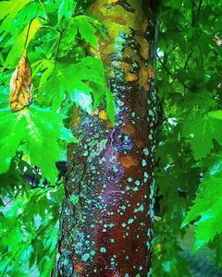

CHAPTER 4. SPECIAL SELECTIONS

283

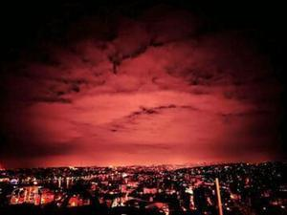

CHAPTER 4. SPECIAL SELECTIONS

284

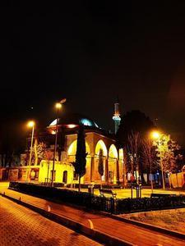

CHAPTER 4. SPECIAL SELECTIONS

285



CHAPTER 4. SPECIAL SELECTIONS

286



CHAPTER 4. SPECIAL SELECTIONS

287

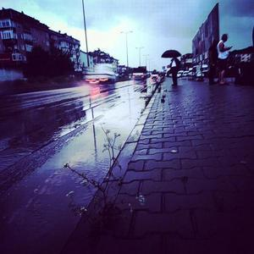

CHAPTER 4. SPECIAL SELECTIONS

288



CHAPTER 4. SPECIAL SELECTIONS

289

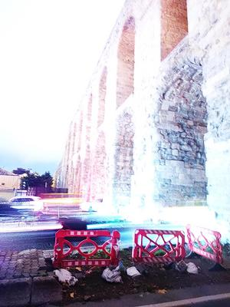

CHAPTER 4. SPECIAL SELECTIONS

290

a

a Same time check how visual differs.



CHAPTER 4. SPECIAL SELECTIONS

291

a

a Same time check how visual differs.



CHAPTER 4. SPECIAL SELECTIONS

292

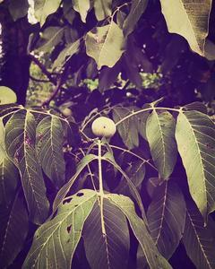

CHAPTER 4. SPECIAL SELECTIONS

293

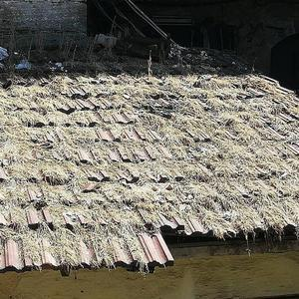

CHAPTER 4. SPECIAL SELECTIONS

294



CHAPTER 4. SPECIAL SELECTIONS

295

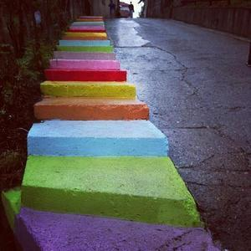

CHAPTER 4. SPECIAL SELECTIONS

296

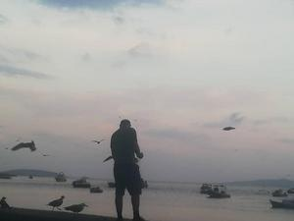

CHAPTER 4. SPECIAL SELECTIONS

297

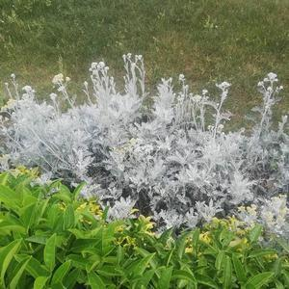

CHAPTER 4. SPECIAL SELECTIONS

298



CHAPTER 4. SPECIAL SELECTIONS

299

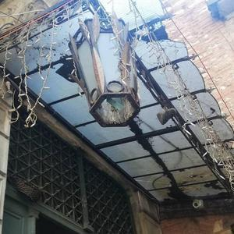

CHAPTER 4. SPECIAL SELECTIONS

300

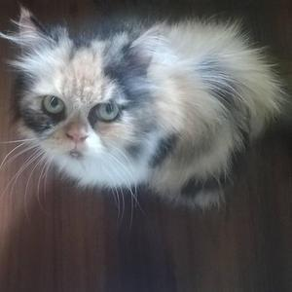

CHAPTER 4. SPECIAL SELECTIONS

301

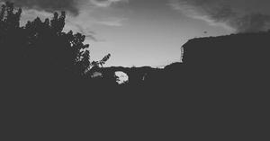

CHAPTER 4. SPECIAL SELECTIONS

302

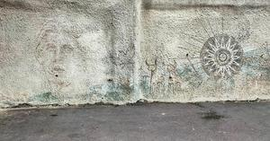

CHAPTER 4. SPECIAL SELECTIONS

303



CHAPTER 4. SPECIAL SELECTIONS

304

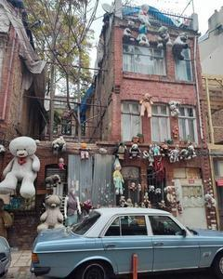

CHAPTER 4. SPECIAL SELECTIONS

305



CHAPTER 4. SPECIAL SELECTIONS

306

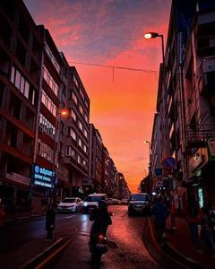

CHAPTER 4. SPECIAL SELECTIONS

307

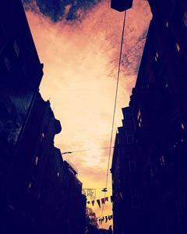

CHAPTER 4. SPECIAL SELECTIONS

308

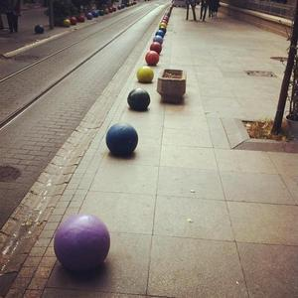

CHAPTER 4. SPECIAL SELECTIONS

309

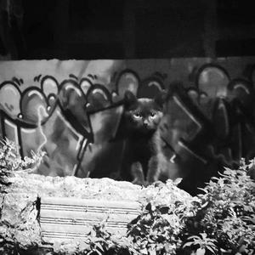

CHAPTER 4. SPECIAL SELECTIONS

310

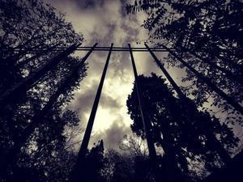

CHAPTER 4. SPECIAL SELECTIONS

311

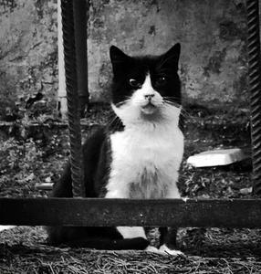

CHAPTER 4. SPECIAL SELECTIONS

312

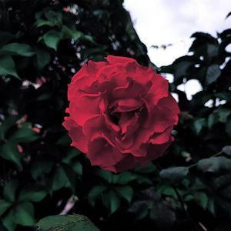

CHAPTER 4. SPECIAL SELECTIONS

313

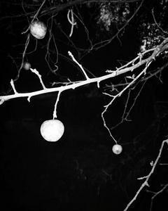

CHAPTER 4. SPECIAL SELECTIONS

314

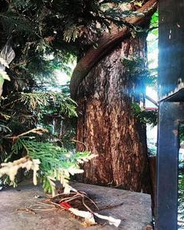

CHAPTER 4. SPECIAL SELECTIONS

315

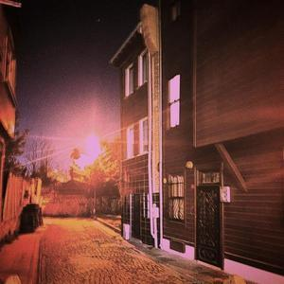

CHAPTER 4. SPECIAL SELECTIONS

316

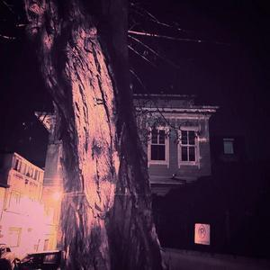

CHAPTER 4. SPECIAL SELECTIONS

317

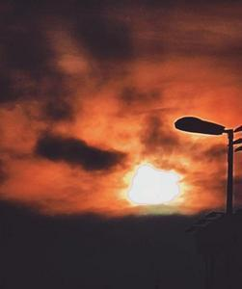

CHAPTER 4. SPECIAL SELECTIONS

318

319

Chapter 5

Future Plans

As I chart the course of my future, I find myself bound by promises I’ve made to myself—commitments that fuel my dedication and shape my journey.

My life unfolds like a

tale of two halves, each offering its own unique narrative.

Through my lens of perception, I glimpse the vast horizon, where countless treasures lie hidden along my path. Here’s a glimpse into some of my aspirations: 5.1

Digital Exhibition - 2D

My first digital exhibition is online now. There will be new digital exhibitions occasionally with some concepts. My second concept will be B-W. that creative endeavours leads me to another creativity. Yet this is just a beginning of my journey.

5.2

Wall Exhibitio

Make a wall exhibition with printed version of my photos.

5.3

Photo tables

Make a small books that contain some photos, 15–20 pages.

1. [Physical print - 1](https://www.youtube.com/watch?v=i_fJ5oBaJcM)

2. [Physical print - 2](https://www.youtube.com/watch?v=kLFk19TRPrU)

CHAPTER 4. SPECIAL SELECTIONS

320

5.4

Digital Exhibition - Personal App

I plan to make a personal mobile app. With that attempt, people can follow my digital exhibitions in specialized app.

The technology I plan to use for that app is CapacitorJS.

5.5

Digital Exhibition Book - Digital

As I mentioned above, digital exhibitions will be carried out repeatedly. And this repeated events provide me great amount of material. When the time comes, there will be a book that gathers all my materials in my book.

5.6

Digital Exhibition Book - Physical

That can be physical, sometimes later.

5.7

Digital Exhibition Book - Digital

As I mentioned above, digital exhibitions will be carried out repeatedly. And this repeated events provide me great amount of material. When the time comes, there will be a book that gathers all my materials in my book.

5.8

Digital Exhibition Book - Physical

That can be physical, sometimes later.

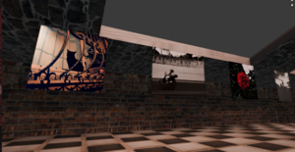

321

5.9

3D Exhibition

Venturing into the realm of three-dimensional artistry, I’m sculpting a virtual exhibition using Blender and Unity. Like its digital counterpart, it will evolve with diverse concepts, inviting viewers into immersive experiences. I plan to extend its reach with web, mobile, and desktop applications, push-ing the boundaries of traditional exhibition and inviting audiences into new dimensions of creativity.

The technology I plan to use for that app is Blender, Unity, Godot or Babylon.js. There are some options I need to examine. Later, I plan to use CapacitorJS for making it a mobile app and ElectronJS for making it a desktop app that will be executable in Windows, Linux, and macOS.

CHAPTER 4. SPECIAL SELECTIONS

322

5.10

Almanac of Memories

In addition to my visual pursuits, I dream of curating an almanac—a collection of unique photographs paired with poignant stories. With hundreds of snapshots capturing fleeting moments, each page will tell a tale, evoking emotions and memories.

5.11

Photography App

There will be a general use photography app. It is still under construction.

5.12

Narrative Endeavors

Beyond visuals, I’m drawn to the world of storytelling. I’m considering crafting a storybook filled with short tales, each weaving a captivating narrative populated by intriguing characters and rich environments.

In pursuing these ambitions, I’m guided by unwavering dedication and fuelled by ambition, integrity, and dignity. As I gaze towards the future, I’m filled with anticipation, eager to see where my path will lead. While uncertainties linger, I embrace the journey with passion and purpose, ready to uncover the treasures that await me.

CHAPTER 4. SPECIAL SELECTIONS

323

Chapter 6

Additional Context

More about me.

• [Github](https://github.com/spinningcat)

• [Linkedin](https://tr.linkedin.com/in/berat-emre-nebio�lu-08a58113)

• [Visuality](https://spinningcat.github.io/Visuality/)

• [Blog](https://spinningcat.github.io/blog/)

• [Youtube](http://www.youtube.com/@2452345245)

• [Instagram](https://www.instagram.com/berratnebioglu/?igsh=MW1mbzJhY3ZkZGRtbQ%3D%3D)

• [Digital Exhibition](https://berat.cloud.mech.cx/digitalexhibition/)

• Contact: beratn@gmail.com

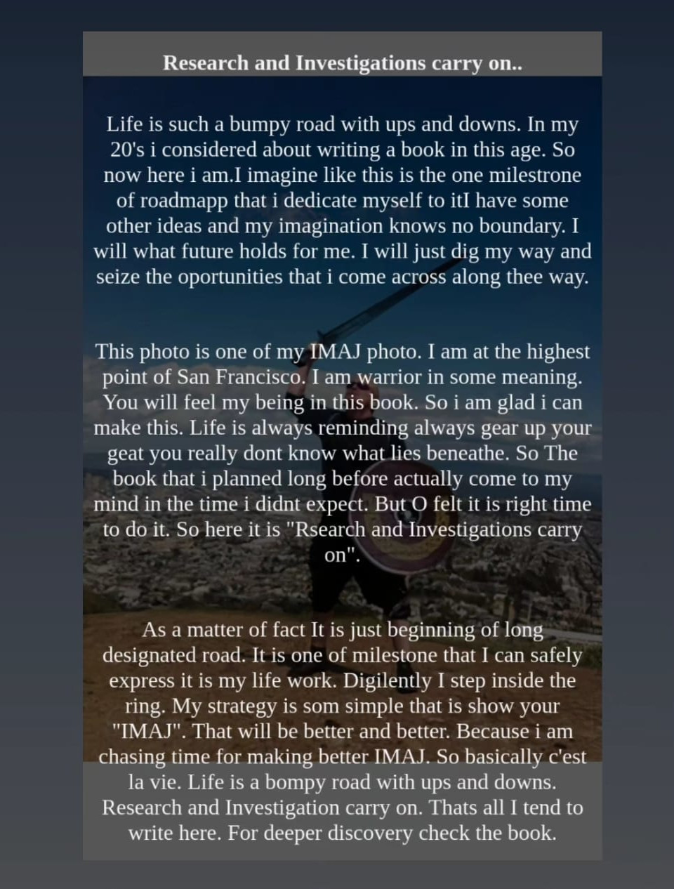

# Document Outline

* Writings, stories and poems
  + Research and investigations will continue.
  + Notes To Myself
    - April 1, 2015
    - April 2, 2015
    - April 3, 2015
    - April 4, 2015
    - April 6, 2015
    - April 8, 2015
    - April 8, 2015
    - April 9, 2015
    - April 10, 2015
  + Notes to myself - 2: I think I'm starting to like this. 
    - April 14, 2014
    - April 15, 2014
    - April 15, 2015
    - April 15, 2015
    - April 17, 2015
    - April 28, 2015
    - April 28, 2015
  + Remember
  + As human beings
  + ... (Unnamed Note)
  + ... (Unnamed Note) - 2
  + Feeling
  + A Pianist's Story
  + I saw a musician on stage the other day.
  + We also have bread...
  + Like Everyone Else
  + The music bond of the little man, who is a traveller on his own path.
  + My freedom is mine.
  + Going into detail is the greatest painkiller.
  + A Soul Awaits, Noticed or Unnoticed. 
    - First Birth, First Gaze into Life
    - A Baby was Born into the World, a New Joy Emerged
    - Being Intertwined with Life
    - Life, a Process We Grow Into
    - How Do We Recognize a Pure Soul?
    - To Be a Pure Soul, Certain Things are required.
    - One Day, Go Outside.
    - Ultimately, the Choice is Yours.
  + The Wine Effect
  + Crying
  + The biggest treasures inside me are apparently hidden in my tears.
  + I Am Still Here.
  + Feeling
  + Shout
  + I have an Endless Melody and Never-ending Breath.
  + The Music Connection of the Little Man on His Journey.
  + Silent Scream
  + Faces...Faces...
  + Sometimes looking at a person's face is enough.
  + Writing a Text
  + I have an endless melody and an endless breath.
  + Hope
  + My Angels in the Darkness
  + A collective poetic essay - Night Swims
  + Elephants and Grass
  + Peter Griffin, Eric Cartman, and Gazoz
* Photographs and stories
  + Selection and Stories
* Categoric Selections
  + Categories
    - City
    - Saturated
    - B-W
    - Animal
    - Experimental
* Special Selections
  + Honorable Mention
    - All Speciality
* Future Plans
  + Digital Exhibition - 2D
  + Wall Exhibitio
  + Photo tables
  + Digital Exhibition - Personal App
  + Digital Exhibition Book - Digital
  + Digital Exhibition Book - Physical
  + Digital Exhibition Book - Digital
  + Digital Exhibition Book - Physical
  + 3D Exhibition
  + Almanac of Memories
  + Photography App
  + Narrative Endeavors
* Additional Context